Annual Progress Seminar Report on
Development and Validation of Narrow-Aisle Robotic and IoT-Based Systems for Warehouse Applications, with a Proposed Framework for Contactless Worker-Fatigue Assessment
(On completion of first year of PhD)
by
ARITRA DAS
Roll No: 25D0074
Under the supervision of
PROF. AMBARISH KUNWAR

Department of Biosciences and Bioengineering
Indian Institute of Technology Bombay
Mumbai, Maharashtra

Acknowledgement
I would like to express my sincere gratitude to my supervisor, Prof. Ambarish Kunwar, for his guidance, for the freedom he allowed me in choosing how to approach this work, and for his patience through a first year in which a great deal of the effort went into finding out what did not work. The direction this project has taken owes a great deal to his suggestions.
I gratefully acknowledge the support of the IITB-FedEx ALFA, Centre for Advanced Logistics and Focused Analytics, Indian Institute of Technology Bombay, under whose fellowship this work was carried out.
I am grateful to the members of the laboratory for their help throughout the year, and for the earlier work on asymmetric wheel geometry carried out in this group, on which the platform reported here is built. I would also like to thank everyone who assisted with the environmental monitoring work, particularly on the design of the chamber the instrumentation serves.

Plagiarism Undertaking
I hereby declare that this submission is entirely my own work, presented in my own words. Any ideas, data, or wording taken from other sources have been appropriately acknowledged and cited, with full references provided. I affirm that I have followed the principles of academic honesty and integrity, and that no part of this submission involves misrepresentation, fabrication, or falsification of information or sources. I understand that failure to comply with these standards may result in disciplinary action by the Institute, as well as possible legal or penal consequences from the concerned sources if proper citation or permission has not been obtained.
Aritra Das
Roll No: 25D0074

Table of Contents
Chapter 1 5
1.1 Introduction 5
1.2 Review of Literature 5
Chapter 2 7
2.1 Introduction 7
2.2 Review of Literature 7
Chapter 3 8
3.1 Introduction 8
3.2 Review of Literature 8
Chapter 4 9
4.1 Motivation 9
4.2 Objectives 10
Chapter 5 11
5.1 The platform and its starting condition 11
5.2 Migration of the drive controller 13
5.3 Level translation on the encoder return path 13
5.4 Kinematic model 15
5.5 Control architecture and software integration 16
5.6 Perception and mapping 17
5.7 Autonomous navigation 17
5.8 Environmental monitoring system 18
5.9 Analysis method 20
Chapter 6 21
6.1 Closed-loop velocity control 21
6.2 Kinematics and motion estimation 23
6.3 Perception 25
6.4 Mapping, and the constraint imposed by the available workspace 26
6.5 Autonomous navigation 29
6.6 Operating without an inertial sensor 29
6.7 Present state of the platform 31
6.8 Environmental monitoring system 32
Chapter 7 33
7.1 Future Work 33
7.2 Year-One Conclusions 34
Bibliography 34

Chapter 1

1.1 Introduction
Warehouse automation has grown around machines that move goods along wide, well-structured routes. The aisle itself has received far less attention, and it is the part of the building where the geometric constraint is hardest. A storage aisle is sized for the goods it holds and for a human picker, not for a vehicle, so a mobile robot working there operates in a corridor barely wider than itself. Clearance is measured in centimetres rather than in metres.
That constraint rules out most drive configurations. A differential-drive or steered platform cannot correct a lateral offset without executing a manoeuvre, and the manoeuvre consumes longitudinal space the corridor does not have. Once such a platform is misaligned inside an aisle, recovering alignment requires either reversing out or a sequence of short forward and backward motions, both of which cost time and both of which risk contact with the racking.
Mecanum wheels remove that limitation. Each wheel carries a set of rollers mounted at forty-five degrees to the wheel axis, so the contact force has a component along the roller axis as well as along the wheel’s rolling direction. Driving the four wheels at different velocities produces net motion in any direction in the plane, including pure lateral translation and rotation about the vehicle centre, without any change in wheel orientation. A mecanum platform can therefore correct a lateral offset by translating sideways, a manoeuvre that in the ideal case requires no fore-aft travel at all.
Mecanum kinematics alone do not solve the aisle problem, because a conventional four-wheel mecanum platform places its wheels at the four corners of a rectangle. The chassis must then be wide enough to carry that rectangle, and the width of the machine is set by the wheel layout rather than by the payload. An alternative layout places the wheels non-collinearly, in a point-symmetric rather than a mirror-symmetric arrangement: one diagonal pair sits farther from the body centre along the vehicle’s long axis than the other. This arrangement preserves the three planar degrees of freedom that make mecanum drive useful while relaxing the packaging constraint that sets vehicle width.
The kinematic basis for this asymmetric arrangement was established in earlier work carried out in this laboratory, which derived the transformation between wheel velocities and body velocity for non-collinear placement and demonstrated it on a small prototype [1]. That work established the geometry and showed that the platform moves as the model predicts. It did not extend to a full-scale machine, to closed-loop velocity regulation at each wheel, or to the perception and navigation layers a working warehouse robot requires. The present work takes that geometry to a full-scale platform and builds those layers on top of it.

1.2 Review of Literature
Omnidirectional platforms and wheel geometry. Mecanum drive is mature as a mechanism and the symmetric four-wheel configuration is standard. Its kinematics, its singularity-free behaviour in the plane, and its sensitivity to wheel slip are all well documented. The asymmetric, non-collinear placement used here is far less common, and the prior work establishing its kinematics for narrow-aisle application is the laboratory study cited above [1]. The consequence of the asymmetry is that the yaw lever arm differs between the two diagonal pairs, so each wheel carries its own coefficient in the inverse kinematics rather than the single shared coefficient of the symmetric case.
Heading drift and the need for closed-loop estimation. Wheel slip is a major source of trajectory and pose-estimation error on mecanum platforms, because the rollers present a small contact patch and slip laterally by design. Galati and co-workers drove a mecanum platform ten metres in open loop on industrial concrete and recorded heading deviations between 3.98 and 4.81 degrees across ten repetitions, with a final lateral error of 0.79 to 0.94 metres; closing the loop on the same platform and the same surface brought those to 0.40 degrees and 0.17 metres [2]. In a corridor with a few centimetres of clearance per side, an open-loop error near a metre is not degraded performance but contact with the racking, and it accumulates within a single aisle traverse. Closed-loop wheel velocity control with a measured pose estimate is therefore a requirement rather than a refinement.
Control of mecanum platforms. Fixed-gain proportional-integral-derivative control at the wheel remains the standard approach and is adequate when the plant is identified and the feedforward term is calibrated against measured data. Adaptive and fuzzy-tuned alternatives have been proposed for mecanum-wheeled platforms [3, 4], and fault-tolerant schemes exist that maintain controllability with one or two wheels disabled [5]. Both classes of work assume a symmetric wheel layout. Whether their results transfer to a platform whose wheel pairs sit at different radii from the centre of mass has not been reported.
Simultaneous localisation and mapping. Two-dimensional lidar SLAM on low-cost hardware is a well-developed field. Graph-based methods maintain a pose graph and optimise it when a place is revisited, and the widely used open-source implementation adopted here descends from that lineage [6, 10]. Particle-filter methods carry one map per particle and scale poorly on embedded hardware, which is why dedicated accelerators have been proposed for them [7, 12, 13]. Scan-matching methods without a pose-graph back end minimise drift going forward but never correct it [8]. Submap-based approaches with global matching are more capable at larger scale [9]. Comparisons on low-cost rotating scanners of the class used in this work report that scan-matching approaches outperform particle-filter methods on that sensor tier [11]. The underlying mathematics, the point-to-line matching metric [14], the nonlinear least-squares pose-graph formulation [15], and the Bayesian occupancy update [16], are standard and are applied unchanged here.
Navigation. The navigation stack used in this work provides behaviour-tree task orchestration over lifecycle-managed components, with collision checking that admits holonomic platforms rather than assuming a differential-drive motion model [17]. Its layered costmap architecture separates the inflation band, which is a cost field expressing path preference, from footprint-based collision checking, which is a separate constraint [18]. That distinction matters disproportionately in a narrow aisle, because an inflation radius chosen generously for safety can make a corridor the machine physically fits appear impassable. For local control, the dynamic-window approach searches a velocity window reachable within the robot’s acceleration limits [19], with known weaknesses in dead ends and U-shaped obstacles [20]; sampling-based predictive control evaluates many sampled trajectories against a cost function and handles omnidirectional motion more naturally [21, 22].

Chapter 2

2.1 Introduction
The second strand of this work concerns the environment inside the warehouse rather than motion through it. Stored goods and the people handling them are both sensitive to air condition. Reviews of post-harvest practice for perishable produce identify storage temperature and relative humidity as the principal levers on quality loss and shelf life, alongside controlled-atmosphere techniques that adjust the surrounding gas composition [27]. Carbon dioxide concentration is a long-established surrogate for ventilation adequacy rather than a direct measurement of it, since indoor concentration rises with occupant respiration and falls with air exchange, and it is used as such in indoor air quality assessment [28]. Particulate load affects both product quality and worker health. In Indian conditions these quantities frequently sit outside the range in which either people or goods do well.
Two considerations motivated this strand. First, environmental variables relevant to storage conditions and worker exposure are measurable but are not necessarily incorporated into the control of air-treatment systems. Second, timer-based operation of treatment equipment provides no feedback from the condition of the air being treated. Such open-loop operation cannot adapt treatment to changing environmental conditions or indicate whether treatment is required. These considerations motivated the development of a closed-loop monitoring and control system in which environmental measurements inform both actuation and operator awareness.
The system reported here was designed, built and deployed for this purpose. It instruments an air treatment unit with continuous multi-parameter sensing, drives the lamp and the airflow from those measurements, and reports over several independent wireless channels operating concurrently, so that failure of any one communications path does not interrupt telemetry. The redundancy is in the reporting paths, not in the sensing node or its power, both of which remain single points of failure. The same architecture is intended to transfer to cold storage, to controlled-atmosphere rooms used for produce ripening, and to general warehouse environmental monitoring, which is the direction in which this strand of the work is intended to develop.

2.2 Review of Literature
Environmental sensing in storage and industrial settings. Multi-parameter environmental monitoring is well established. Low-cost non-dispersive infrared sensors give carbon dioxide measurement stable enough for indoor assessment, and an evaluation of several current parts over several months found good agreement between them despite differences in construction, factory calibration and price [29]. Optical particle counters give particulate mass concentration, and combined temperature and humidity parts are inexpensive and adequate. Non-selective metal-oxide gas sensors are cheaper still but respond to a mixture of reducing gases rather than to any one species, which is why the index they produce is treated in this work as a relative signal rather than a concentration. The engineering difficulty is rarely the individual sensor. It lies in integration, in calibration, in keeping a deployed system reporting reliably without attention, and in ensuring that the quantity driving a control decision is the quantity that actually matters.
Communication architecture. Facility monitoring systems typically choose between local wireless networking, long-range low-power radio, and cellular connectivity, and typically arrange them as a failover chain. A failover design must detect failure before it can switch, and detection is the first thing to fail in a dead network. Running independent channels concurrently avoids that dependency at a bandwidth cost that a low-rate telemetry system can absorb.
Local processing against cloud dependency. Cloud-hosted monitoring is convenient and is the common commercial pattern, but it makes continuity of monitoring dependent on external connectivity. For a facility where the monitored condition matters most during a disruption, that dependency is misplaced. A locally hosted data platform removes it.

Chapter 3

3.1 Introduction
The third strand concerns the people working in the aisle. Physical fatigue accumulated over a shift degrades both safety and throughput, and in warehouse work it develops under conditions that make it worse: sustained walking and lifting, limited rest, and ambient heat that in Indian facilities regularly exceeds comfortable limits. Occupational heat stress in Indian workplaces has been measured directly, with documented exceedances of established thresholds and associated health and productivity consequences [23], and comparable findings are reported across steel [24], construction [25] and multi-sector southern-Indian settings [26].
Fatigue monitoring as currently practised does not transfer to this setting. The established laboratory methods are contact-based [30], and the established field systems address seated drivers rather than walking workers [31]. The objections to instrumenting the worker instead of the space are practical rather than evidential, and are given here as the design reasoning behind the approach rather than as findings: a sensor worn against the skin for an eight-hour shift in the ambient conditions described above is uncomfortable, electrode contact and signal quality degrade with perspiration, compliance depends on the worker choosing to wear it, and a facility employing hundreds of people acquires a daily charging and maintenance burden. None of these is fatal alone. Together they are why this strand asks whether the measurement can be made without contact at all.
The hypothesis examined in this strand is that information sufficient for the same purpose can be recovered without contact, by instrumenting the environment rather than the worker. At the time of writing this strand consists of a formulated hypothesis and a completed literature survey. No hardware has been built and no data has been collected. It is carried in this report as a proposed direction, and the implementation is described in Chapter 7.

3.2 Review of Literature
Contact-based fatigue measurement. Surface electromyography combined with inertial measurement is the established laboratory approach and gives good discrimination under controlled conditions: a recent multimodal system fusing both through a hybrid convolutional and recurrent model reports 87.9 per cent accuracy on induced fatigue under leave-one-subject-out validation across 35 participants [30]. The requirement for skin-contact electrodes and per-subject placement is what prevents its use on an operating warehouse floor.
Driver drowsiness systems. The most mature deployed fatigue systems monitor drivers. Thermal facial imaging alone reaches 82 per cent accuracy against observer-rated drowsiness in a driving simulator by tracking forehead and cheek temperature [31], and wearable systems fuse physiological channels for the same purpose [32]. These assume a seated, stationary, forward-facing and cooperative subject at a fixed distance from the sensor. A worker walking an aisle under load satisfies none of those assumptions.
Contactless modalities. Several sensing modalities can observe a person without contact, and their reported accuracies are the starting point for what a fused estimate could achieve. Camera-based pose estimation recovers joint angles and gait parameters from ordinary video, with mean absolute errors against marker-based motion capture of 0.02 s on temporal parameters and 4.0, 5.6 and 7.4 degrees on sagittal hip, knee and ankle angles [33]. Lidar gives three-dimensional gait measurement robust to illumination, and a point-cloud gait benchmark establishes that the signal carries enough information to identify individuals [34], which is a capability this strand would have to constrain deliberately rather than a feature to exploit. Millimetre-wave radar recovers respiration and heart rates without contact, correlating with a reference sensor at 94 and 80 per cent respectively [35], although those accuracies are established for near-stationary subjects and degrade with body motion, which the surveyed literature treats as an open problem rather than a solved one [36]. Thermal imaging responds to surface temperature and therefore to thermal strain, and has been used to detect exercise-induced fatigue directly [37], subject to the absolute accuracy limits of low-cost sensors.
The gap this strand proposes to address is the fusion of these modalities for whole-body physical fatigue assessment in an uncontrolled industrial environment. No study meeting the criteria used in this review was identified. That review covered the publication record indexed through Crossref and the scite database, searched between June and September 2026 on combinations of fatigue, gait, thermal imaging, millimetre-wave radar and lidar with industrial, occupational and warehouse qualifiers, and admitted peer-reviewed work only. It is a bounded search rather than an exhaustive one, and the claim should be read as such.

Chapter 4

4.1 Motivation
A robot that can work inside a storage aisle addresses a part of the warehouse that current automation largely avoids. The aisle is where inventory is counted, where goods are picked and replaced, and where the environment is least controlled, and it is precisely the space in which conventional mobile platforms are hardest to deploy. A machine that holds its lateral position in a sub-metre corridor, carries a useful load, and knows where it is well enough to navigate without a human operator would make several distinct warehouse tasks automatable with one platform: inventory scanning, environmental survey, surface disinfection, and cargo transfer between a rack and a pick point.
The geometric premise for such a machine already exists. Earlier work in this laboratory derived the kinematics for an asymmetric, non-collinear mecanum layout intended for narrow aisles and demonstrated the principle on a prototype [1]. What that work did not establish is whether the geometry survives the transition to a full-scale machine. A prototype demonstrates that the transformation between wheel and body velocity is correct. It does not show that four geared motors driving a 45.54 kg machine will track commanded velocities accurately, that the resulting pose estimate will be good enough to navigate on, or that a perception stack can be built on top without the asymmetry causing trouble. Those questions require a built machine, closed-loop control at every wheel, and measurement.
This motivates the primary strand of the work: to take the asymmetric geometry from a demonstrated principle to a characterised, autonomous, full-scale platform, and to measure what the asymmetry costs and what it delivers.
Two further considerations motivate the supporting strands. First, a warehouse robot that moves through an environment is more useful if the environment itself is measured, and the instrumentation skills involved transfer directly between the two problems: multi-sensor integration, calibration, real-time acquisition, and closed-loop control with safety interlocks are common to both. Second, the people sharing the aisle with such a machine work under measurable physical strain, and a monitoring approach that does not require them to wear anything would be deployable in a way that current methods are not.

4.2 Objectives
Objective 1: Development and experimental characterisation of a full-scale asymmetric mecanum platform for narrow-aisle operation
To build a full-scale mobile robot on the asymmetric non-collinear wheel geometry, to implement closed-loop velocity control at each wheel with calibrated feedforward, and to characterise the resulting trajectory-tracking and motion-estimation accuracy against independently measured physical references.
Objective 2: Localisation and autonomous navigation at corridor-width clearances
To establish a pose estimate sufficient for autonomous operation in a corridor whose clearance is comparable to the platform’s own turning envelope, to determine what sensing that estimate requires, and to demonstrate goal-directed autonomous navigation on the built platform.
Objective 3: Quantification of the cost and benefit of the asymmetric wheel layout
To compare the asymmetric platform against a symmetric layout of matched mass, wheel and controller parameters, and to establish whether the geometric benefit is obtained without penalty in tracking accuracy, disturbance rejection or yaw authority.
Objective 4: An instrumented, closed-loop environmental monitoring system for warehouse environments
To design, build and deploy a multi-parameter environmental monitoring and control system that drives actuation from measured air condition rather than from elapsed time, reports over independent communication channels, and is applicable to storage, cold-chain and controlled-atmosphere environments.
Objective 5: A contactless framework for assessing worker fatigue
To establish whether physical fatigue in warehouse workers can be assessed from contactless sensing alone, without any worn instrumentation, and to develop and validate a sensing configuration suitable for deployment on an operating floor.

Chapter 5

5.1 The platform and its starting condition
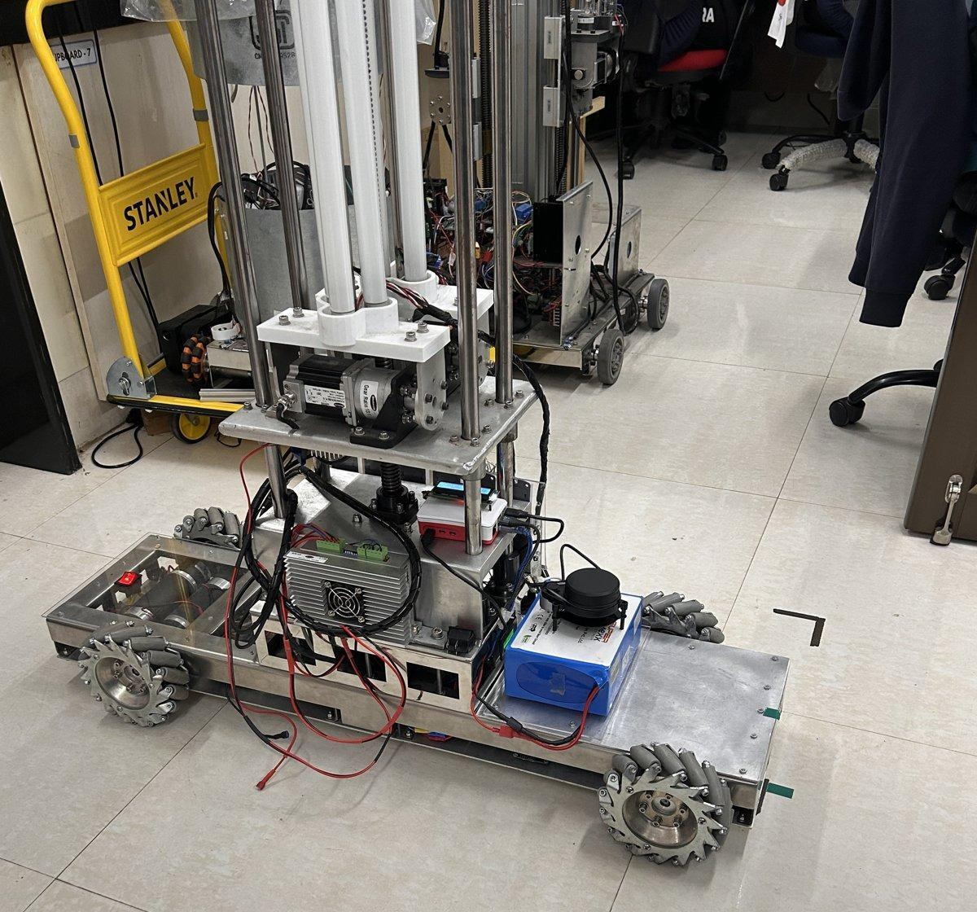
The machine as built
Figure 1. The platform as built, photographed on 11 August 2026. The chassis is 1.00 m long and 0.36 m wide across the wheels, and the four mecanum wheels sit non-collinearly rather than at the corners of a rectangle. The vertical mast carries the three ultraviolet tubes and the stepper axis of the cargo arm; the mast and its payload sit within the plane of the scanner, which is the black unit above the battery, and are the cause of the self-occlusion sector measured in Section 6.3. The ultraviolet lighting carried here is a payload application of the platform and is a separate system from the air-treatment unit of Section 5.8.
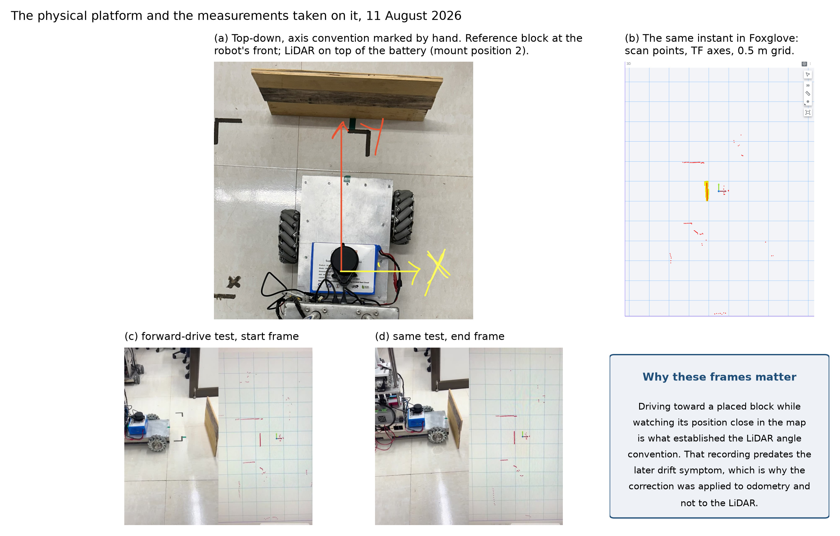
The physical platform
Figure 2. The platform during hardware trials. Panel (a) is a top-down view with the body axis convention marked and the lidar at its mounting position above the battery. Panel (b) is the corresponding view in the visualiser. Panels (c) and (d) are the start and end frames of the forward-drive test used to establish the lidar angular convention.
Work began from an assembled mechanical platform. The chassis, the four mecanum wheels on the asymmetric layout, the four geared drive motors, the two motor drivers and the power system were all present. Control of the motor drivers at that point was performed by an Arduino Mega 2560, and the platform had no closed-loop velocity regulation, no odometry, no on-board kinematic model, no perception, and no autonomy. Everything reported beyond that point, the firmware, the ROS 2 software, the instrumentation and every measurement quoted in this report, was carried out by the author.
The specification below describes the machine as it stands at the end of the reporting period.
Item | Value
Footprint, tape-measured | 1.00 × 0.36 m
Mass | 45.54 kg
Outer and inner wheel longitudinal distance | 0.403 m and 0.333 m
Half track width | 0.15769 m, identical for all four wheels
Wheel radius | 0.0762 m
Drive motors | 4 × geared DC, 24 V, 1:47 reduction, 60 rpm rated
Encoders | Front pair GTK08, 186,264 counts per revolution at the wheel; rear pair optical, 93,132
Motor drivers | 2 × dual-channel, 20 A continuous, 1.5 V logic threshold
Real-time controller | ESP32, 100 Hz control loop, hardware quadrature decoding
Host computer | Raspberry Pi 5, Ubuntu 24.04, ROS 2
Lidar | YDLIDAR X4 Pro, single-plane triangulation, 360°, 0.12–10 m rated range, manufacturer-stated 2 cm absolute below 1 m and 3.5 % of range from 1 to 6 m
Power | LiFePO₄ 12.8 V, 30 Ah, with boost to 24 V drive and buck to 5 V logic
Cargo arm and lighting | Two lateral and one vertical stepper axis, three-tube staged ultraviolet lighting
Operating velocity limit | 0.12 m/s linear, 0.30 rad/s yaw

5.2 Migration of the drive controller
Moving motor control from the Arduino Mega to an ESP32 was the first substantial change made, and the reason is quantitative.
The two front motors carry GTK08 encoders producing 186,264 counts per revolution at the wheel, and the two rear motors optical encoders producing 93,132, in both cases after full quadrature decoding and the gear reduction. At the rated speed the output shaft turns once per second, so the four motors together emit 558,792 counted edges per second. An ATmega2560 runs at 16 MHz, which is 16 million instruction cycles per second. Servicing that edge rate in interrupts leaves approximately 29 cycles per edge for interrupt entry, register save, quadrature decode, counter update and return, before a single cycle is spent on the velocity loop, the serial protocol or the safety logic. A minimal interrupt service routine on that architecture does not fit within that budget. Encoder counting alone saturates the processor.
The ESP32 removes the problem rather than optimising around it. Its pulse counter peripheral decodes quadrature in hardware and maintains the count without processor involvement, across four independent units, one per motor. The processor is then free for the control loop, which runs at 100 Hz, and for the serial link to the host computer. Two further properties of the part were useful: substantially greater processing capability and memory than the part it replaced, and an integrated 2.4 GHz Wi-Fi radio, which allowed the first phone-based control surface to be hosted on the controller itself, before the host computer of Section 5.5 was introduced.

5.3 Level translation on the encoder return path
The controller change created an interface problem that the previous arrangement did not have. An ATmega2560 operates at 5 V logic and accepts a 5 V encoder output directly. The ESP32 does not: its input pins are 3.3 V parts with an absolute maximum close to 3.6 V, and they are not tolerant of 5 V signals. The encoders fitted to this platform produce an output close to 4.7 V. Applying the measured encoder output directly to a 3.3 V input exceeds its specified limit and risks permanent damage.
All eight encoder channels, being the two quadrature channels of each of the four motors, therefore pass through an eight-channel bidirectional level translator. The deployed hardware is a discrete-transistor board with separate low-voltage and high-voltage supply rails.
One asymmetry in this arrangement is deliberate. Only the feedback direction requires translation. The motor drivers have a logic threshold of 1.5 V and accept the 3.3 V drive and direction signals directly, so the command path runs without translation and the translator sits only on the encoder returns. Fewer components in the command path is worth having, because a fault in the command path moves the machine while a fault in the feedback path only misreports it.
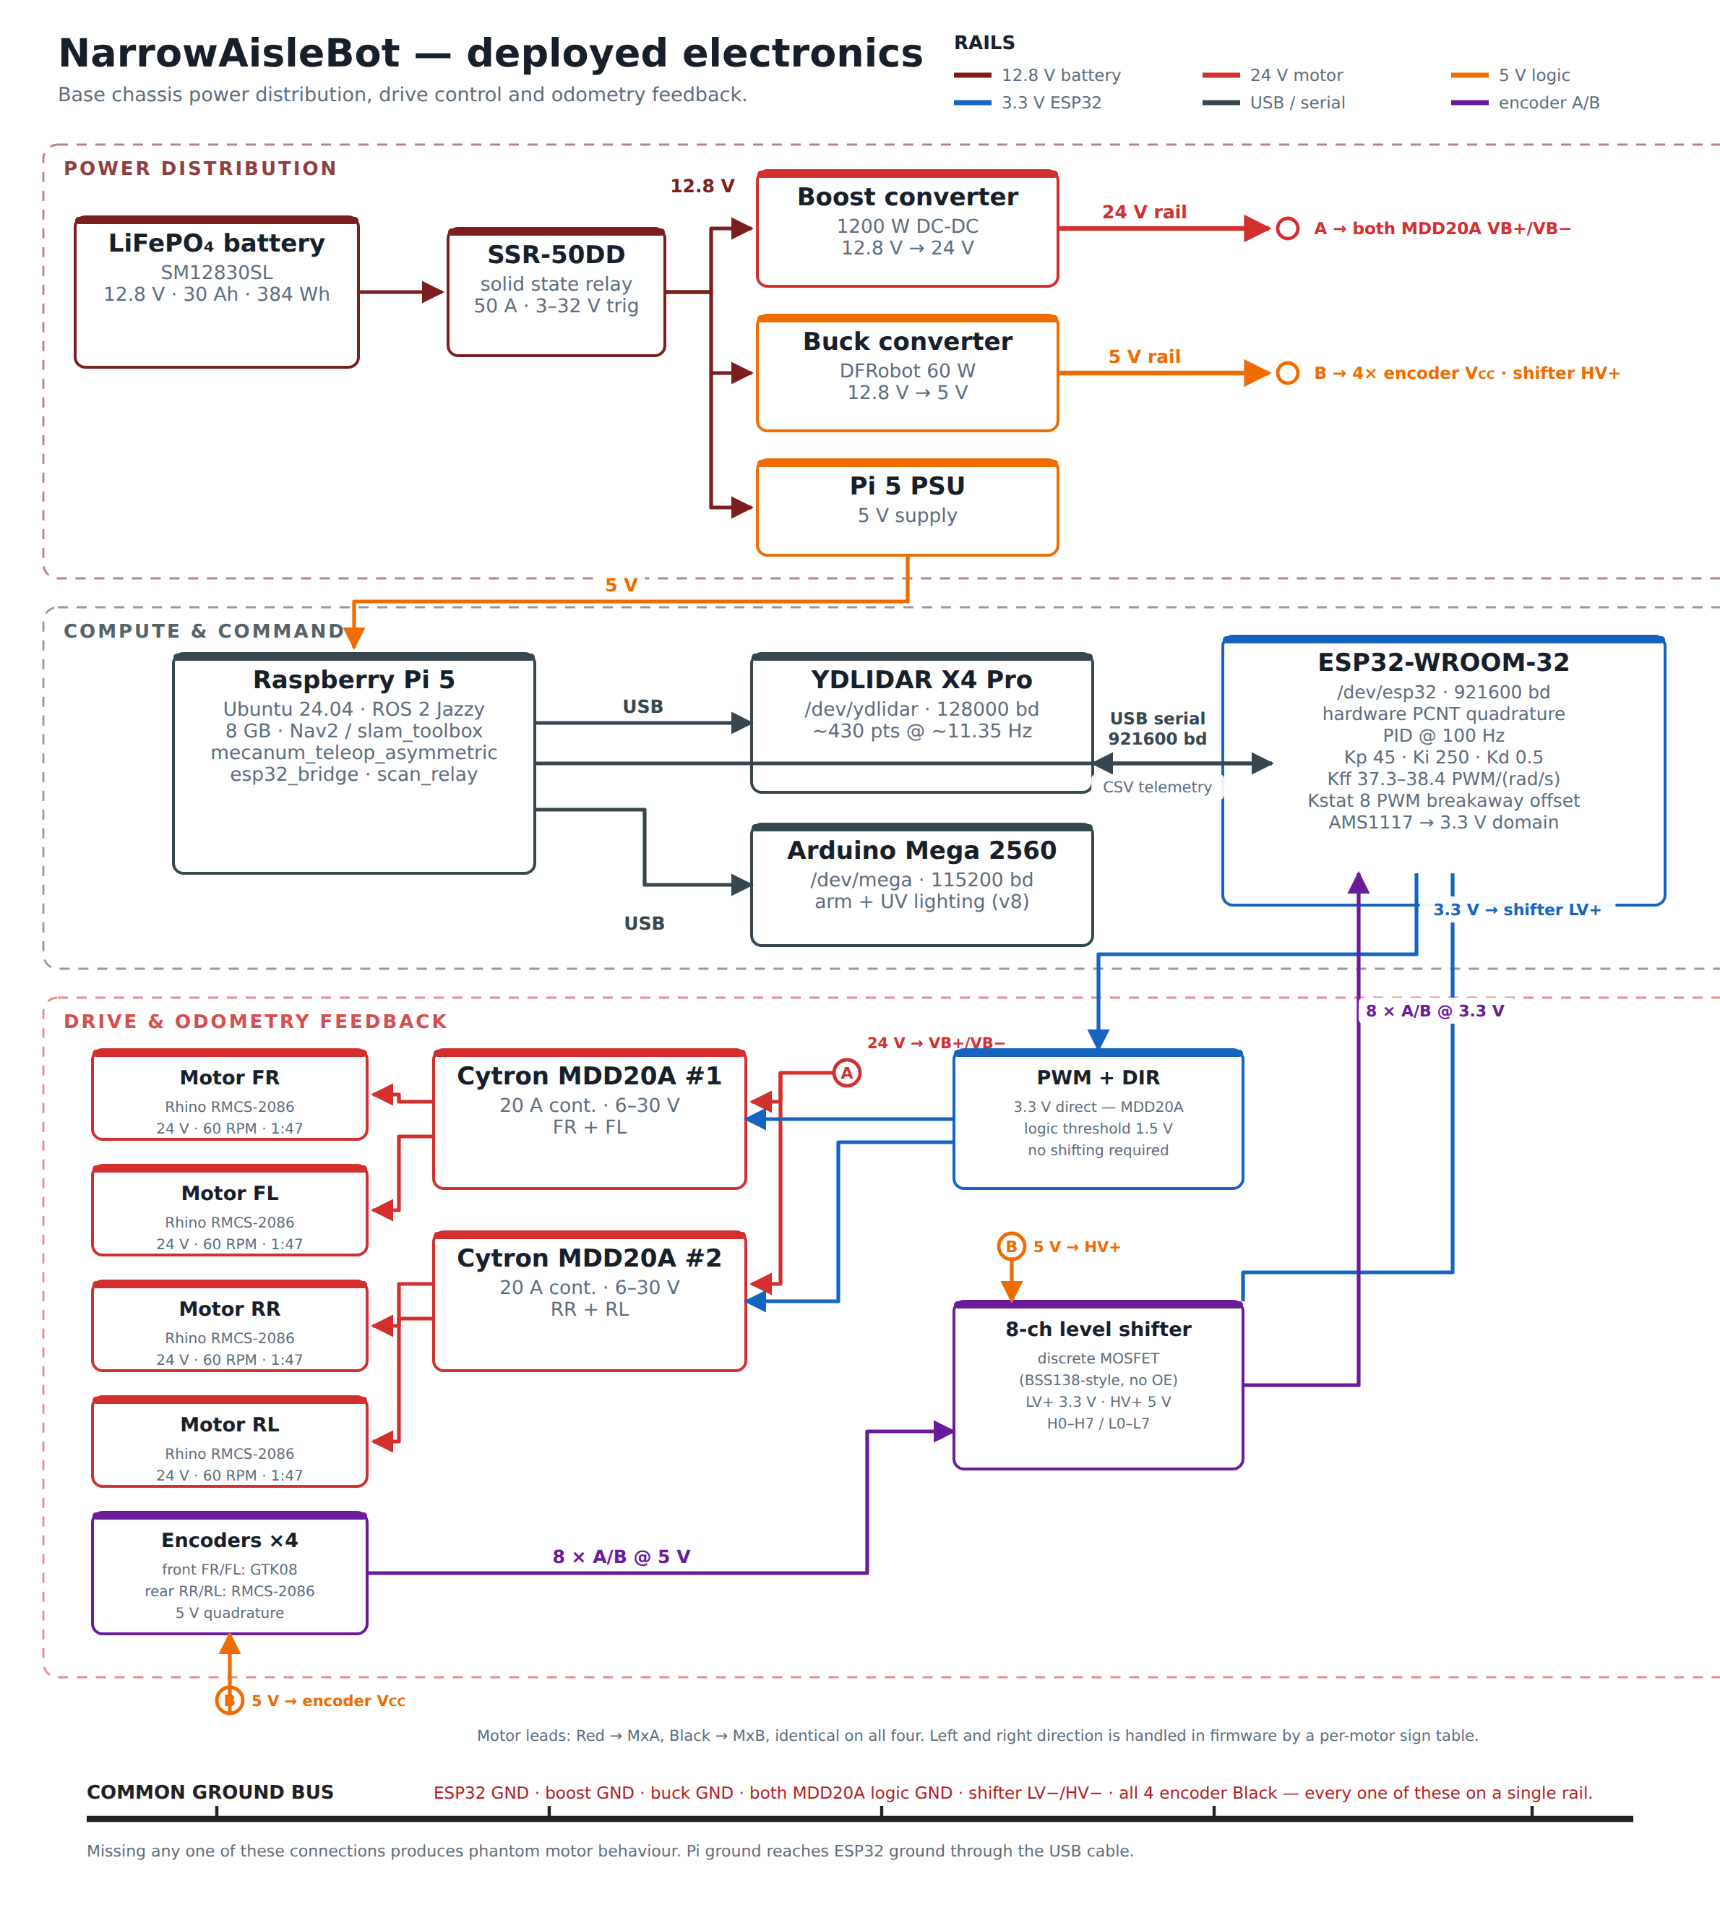
Deployed electronics
Figure 3. The deployed electronics, organised in three layers: power distribution, compute and command, and drive with odometry feedback, each on its own rail colour. The front and rear motors carry encoders of different resolution and different wiring convention, which is recorded explicitly because the difference has caused a channel to be miswired during commissioning.

5.4 Kinematic model
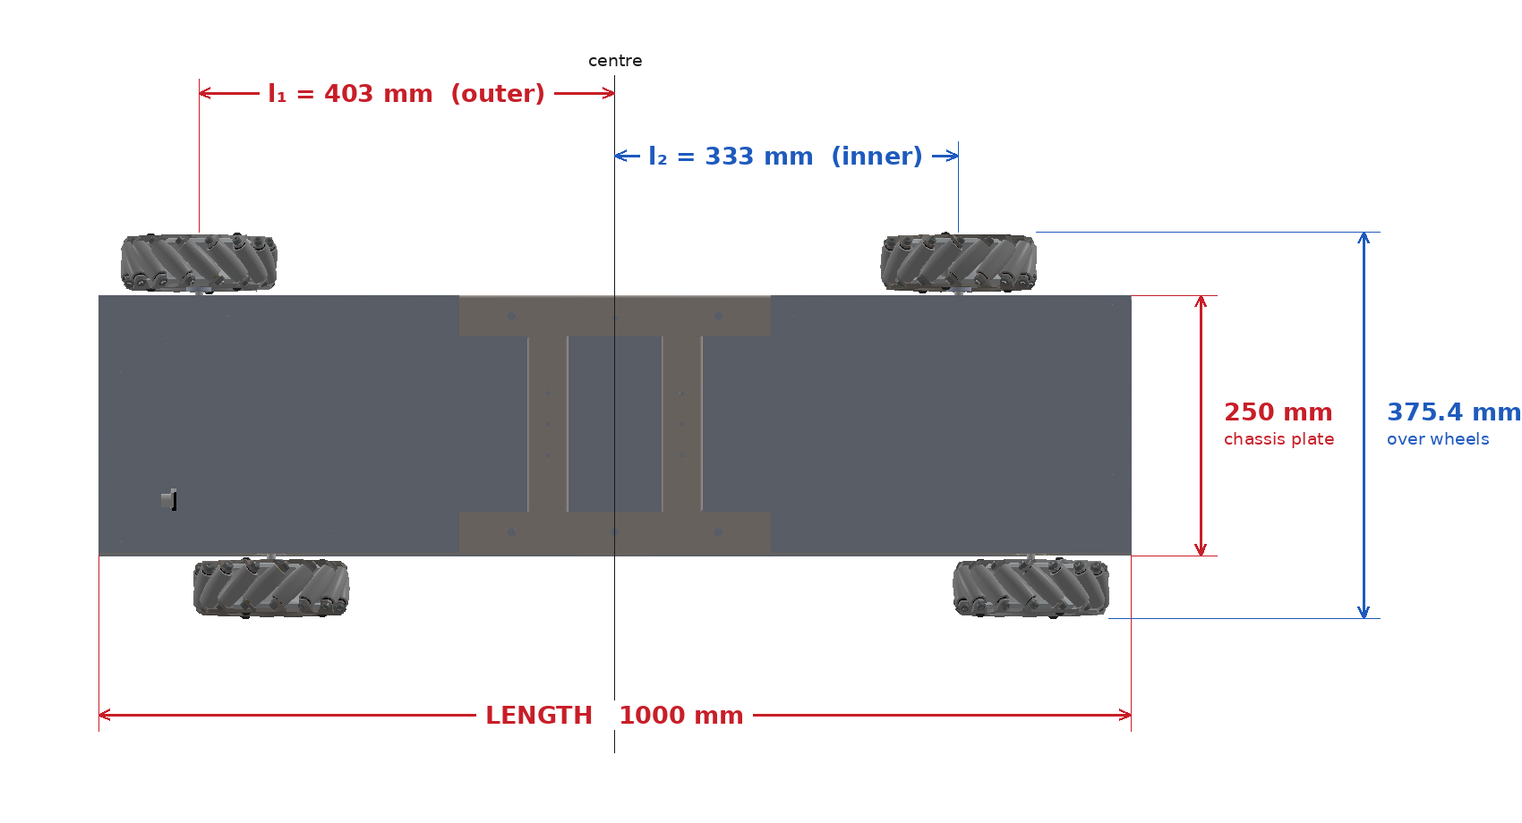
Asymmetric wheelbase geometry
Figure 4. Dimensioned plan view of the wheel layout, taken from the mechanical assembly. The outer diagonal pair sits 403 mm from the body centre along the longitudinal axis and the inner pair 333 mm, an offset of 70 mm. The half track width is the same for all four wheels. Two width figures appear in this report and they measure the same span by different means. The 360 mm quoted in the hardware table of Section 5.1, and used for the collision footprint, is the tape measurement of the built machine, wheel outer to wheel outer. The 375.4 mm marked here is derived from the assembly, being twice the 157.69 mm half track plus two 30 mm wheel half-widths. The two differ by 15.4 mm, and the tape figure is the one every experimental result in this report is referenced to.
The four wheels do not sit at the corners of a rectangle. The outer diagonal pair, front-right and rear-left, sits at a longitudinal distance l₁ = 0.403 m from the body centre; the inner pair, front-left and rear-right, sits at l₂ = 0.333 m. The half track width d = 0.15769 m is common to all four wheels and the wheel radius r is 0.0762 m. Two derived constants carry the asymmetry through every equation that follows:
$$K_{\text{o}}=l_{\text{1}}+d=0.5607\text{ m, }K_{\text{i}}=l_{\text{2}}+d=0.4907\text{ m}$$
For a commanded body twist of forward velocity u, lateral velocity v and yaw rate ω, the four wheel angular velocities are
$$ω_{\text{FR}}=1/r\left(u+v+ωK_{\text{o}}\right)\text{, }ω_{\text{FL}}=1/r\left(u-v-ωK_{\text{i}}\right)\text{,}$$
$$ω_{\text{RR}}=1/r\left(u-v+ωK_{\text{i}}\right)\text{, }ω_{\text{RL}}=1/r\left(u+v-ωK_{\text{o}}\right)\text{.}$$
Each wheel therefore carries its own yaw coefficient, which is the practical consequence of the asymmetry. Substituting a single shared coefficient anywhere in the software reduces the machine, in that code path alone, to an ordinary symmetric mecanum platform.
Inverting this system recovers the body twist from the four measured wheel velocities, and this inverse is what the odometry integrates. The asymmetry produces one useful additional result. The first and fourth rows of the inverse kinematic matrix share the translational term and the second and third rows share its complement, so each diagonal pair yields an independent estimate of yaw rate on its own lever arm:
$${\hat{ω}}_{\text{outer}}=\frac{r\left(ω_{\text{FR}}-ω_{\text{RL}}\right)}{2K_{\text{o}}}\text{, }{\hat{ω}}_{\text{inner}}=\frac{r\left(ω_{\text{RR}}-ω_{\text{FL}}\right)}{2K_{\text{i}}}$$
The mean of the two is the published yaw rate. Their difference is an encoder-derived yaw-consistency residual, obtained without any additional sensor, and it is sensitive to differential wheel slip. It is not a calibrated measurement of slip alone: unequal effective wheel radii, encoder scale error, backlash and mechanical compliance all contribute to the same residual, and separating them requires an external reference.
What the asymmetry contributes here is worth stating narrowly, because it is easy to overstate. The two estimates are formed from disjoint pairs of wheels, which is what makes them separate estimates at all, rather than from the lever arms differing. They are not statistically independent, since a disturbance common to both pairs enters both. A symmetric four-wheel mecanum platform carries a residual of exactly the same form, and it does not vanish there either once slip and measurement error are present. What the differing lever arms change is the weighting. Writing each measured pair difference as its ideal value plus an error term δ, the residual is
$$e_{ω}=\frac{r}{2}\left(\frac{δ_{\text{outer}}}{K_{\text{o}}}-\frac{δ_{\text{inner}}}{K_{\text{i}}}\right)$$
On a symmetric platform K_o and K_i are equal, the two error terms enter with identical weight, and any component common to both pairs cancels exactly. Here they enter with different weights, so a common-mode component survives, scaled by (r/2)(1/K_o − 1/K_i), which for this geometry is 0.0097. The asymmetry therefore does not create the observable; it makes the residual sensitive to a class of error that a symmetric layout cancels, at roughly one per cent of the magnitude of that error. Whether that sensitivity is useful for drivetrain diagnostics is a question for measurement rather than for algebra, and Section 6.2 reports what the residual actually did across four drives.

5.5 Control architecture and software integration
Velocity control runs on the ESP32 at 100 Hz. Each wheel has an independent proportional-integral-derivative loop with a two-term feedforward model, the first term accounting for static friction breakaway and the second for the speed-proportional demand. Feedforward parameters were fitted from measured open-loop data rather than assumed.
A Raspberry Pi 5 running ROS 2 was introduced as the planning and perception computer, with the ESP32 retained for real-time control. The division follows directly from the timing argument of Section 5.2: work that must happen on a fixed schedule sits on the microcontroller, and work that benefits from an operating system sits on the host. The software developed comprises a serial bridge to the motor controller, a second bridge to the arm controller, the asymmetric teleoperation node implementing the inverse kinematics above, an odometry publisher, telemetry logging, a scan relay that republishes the lidar scan with the self-occlusion mask of Section 5.6 applied, and an operator dashboard served from the robot itself with click-to-goal command entry.
The dashboard reaches the robot without any external network. The host computer runs its own Wi-Fi access point, so a phone joins the robot directly, and one page carries the drive joystick, the yaw control, the live map and click-to-goal entry. Whichever source holds control, the asymmetric inverse kinematics of Section 5.4 are evaluated once, in the teleoperation node on the host.
An earlier arrangement hosted a joystick page on the motor controller’s own radio instead, and that was the first control surface the machine had. It was removed when the host became the single command source. That path applied one shared coefficient rather than the two the geometry requires, so it never carried the asymmetry the platform is built around, and it was also the only point at which two writers could contend for the same wheel setpoints.
The cargo arm and the three-tube staged ultraviolet lighting are retained on the original Arduino Mega, which was reassigned to the payload rather than discarded. The lighting is sequenced on that controller so that the staging survives loss of the serial link, with a latched emergency stop.

5.6 Perception and mapping
The platform carries a YDLIDAR X4 Pro, a single-plane triangulation scanner. Three properties of the installed sensor were measured rather than assumed, because each affects what the mapping layer can achieve. The scanner returns approximately 430 points per revolution at 11.35 Hz and does not respond to a commanded scan rate. The manufacturer states 2 cm absolute accuracy below 1 m and 3.5 per cent of range between 1 and 6 m, with nothing specified beyond 6 m despite a 10 m rated range. That figure is a factory acceptance condition rather than a runtime error distribution, so rather than extrapolate from it the stationary scatter of the installed unit was measured directly. The robot was parked with nothing moving in the room and every ray logged for 60 s; scatter is reported per range bin as the spread of a given bearing’s returned range across consecutive sweeps, which is a different statistic from the manufacturer’s mean relative accuracy over a fixed reflectance target. Below 1.5 m the unit is solid in both captures, at 12 to 14 mm. In the 1.5 to 2.0 m band the first capture gives 22.3 mm and a second capture, taken from a differently obstructed parking spot, gives 31.9 mm, which fails the 25 mm half-cell criterion the occupancy resolution implies. Beyond 2.5 m both captures return 55 to 200 mm and do not agree with each other. Neither a linear nor a quadratic degradation model reproduces that pattern, since both predict a single smooth curve. The behaviour is scene-dependent and is not explained by range alone in these captures, which is itself the result: a range cap derived in one position is a fact about that position until it reproduces elsewhere.
The robot occludes its own scanner over part of the sweep, because the mast and payload sit within the scan plane. The blind sector was measured at five independent headings and is a wedge of approximately 90 degrees covering 107 of the 430 returned beams. Those beams are masked in software before the scan reaches the mapping layer, because an unmasked self-return is interpreted as a stationary obstacle travelling with the robot.
Mapping uses a graph-based two-dimensional SLAM implementation, with occupancy maintained by the standard Bayesian log-odds update.

5.7 Autonomous navigation
Navigation uses a behaviour-tree task orchestrator over lifecycle-managed components, with a global planner producing a route through the costmap and a local controller producing velocity commands that follow it. The collision footprint was set from tape measurement of the built machine rather than from nominal dimensions.
The local controller was changed during the work. A dynamic-window controller was adopted first, on the reasoning that it is computationally lighter. It was replaced with a sampling-based predictive controller after the deployed dynamic-window configuration was found to stall on rotation-only goals. Its rotate-to-goal critic invalidates candidates carrying translational motion in the final phase, and because that configuration sampled velocities on a full cross-product grid, only a small fraction of candidates survived the test. This is a property of the configuration rather than of the dynamic-window approach as such: the critic’s behaviour depends on the goal tolerance, the velocity sample set and the simulation horizon, none of which were varied before the controller was replaced. The replacement evaluates sampled trajectories additively against a cost function, so that particular failure mode cannot arise, and it samples the lateral axis directly rather than as a coarse discretisation, which suits an omnidirectional platform.
Commands from the planner, from the operator dashboard and from the manual joystick converge through a priority multiplexer into the same inverse kinematics, so that manual override outranks the planner at the single point where the two meet.

5.8 Environmental monitoring system
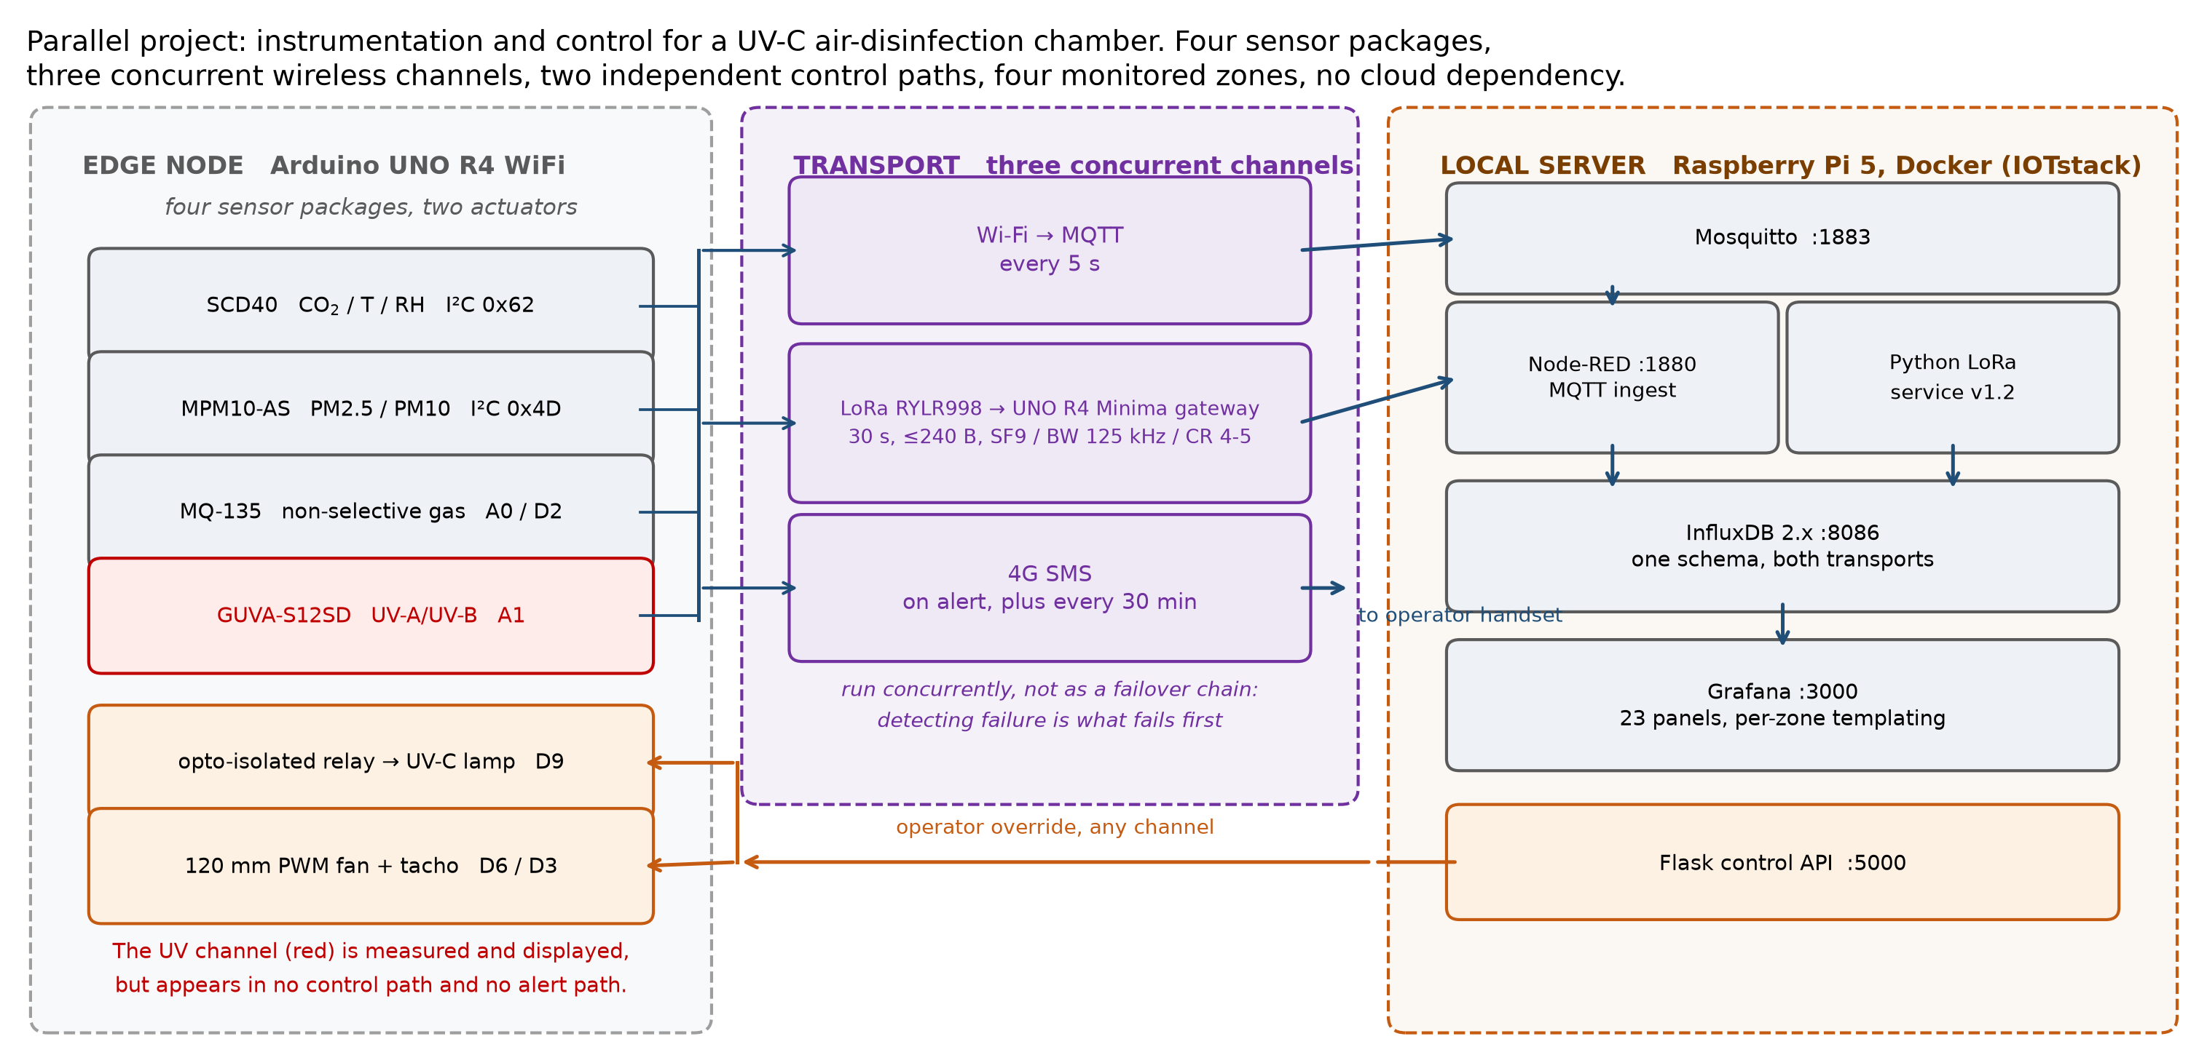
Monitoring system architecture
Figure 5. Architecture of the environmental monitoring and control system: edge sensing node, three concurrent communication channels, and the local server hosting ingestion, storage and the operator dashboard.
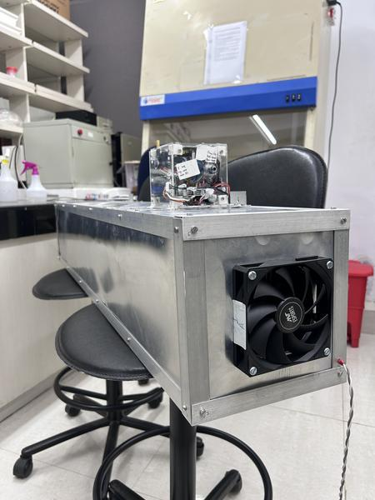
The unit as built
Figure 6. The air-treatment unit as built, photographed in the laboratory. The sensing and control enclosure is mounted on top of the closed treatment chamber, with the fan set into the end face. This is a standalone unit and is not carried on the robot; the ultraviolet lighting visible on the platform in Figure 1 is a separate payload application of that machine.
The monitoring system was built from nothing over the same period. No hardware, firmware, server or dashboard existed at the start. The work comprised selection of the sensor complement against the measurement requirement; electrical integration of four sensor packages, a mains-switching relay and a fan with tachometer feedback onto a single microcontroller, including the serial bus layout and an isolated power architecture; firmware for two separate targets, the sensing node and the radio gateway; configuration of a Raspberry Pi from a bare operating system into a containerised data platform running a message broker, a flow engine, a time-series database, a dashboard server and a control interface; the three concurrent telemetry channels and the reverse command path that runs through them; a multi-panel operator dashboard with per-zone templating and in-panel actuator control; deployment as managed services that survive a power cycle without intervention; and replication of the whole arrangement across a second radio-isolated deployment sharing one database.
Item | Specification
Sensing node | Single-board microcontroller with integrated Wi-Fi
Gateway | Second microcontroller with a long-range LoRa module, level-translated
Server | Raspberry Pi 5, containerised data platform
Measured quantities | Carbon dioxide, temperature, relative humidity, particulate mass at two size fractions, and a non-selective gas index
Actuators | Opto-isolated relay for the lamp supply and a variable-speed fan with tachometer feedback
Channels | Local Wi-Fi at 5 s, long-range LoRa at 30 s, cellular messaging on alert
Control law | Hysteresis with a dead band, with fan speed scaled across the upper part of the index range
Zones | Four, across two radio-isolated deployments against a shared database

Three design decisions were responses to observed failures rather than anticipatory choices. Driving the long-range radio directly from the host computer’s general-purpose pins was attempted and abandoned, because the command protocol requires deterministic timing that a non-real-time operating system does not provide, and scheduler jitter produced dropped packets that were indistinguishable from radio link failures; interposing a dedicated microcontroller moved the timing-critical work to where timing is deterministic. The cellular modem draws approximately 2 A in transmit bursts, and sharing a supply rail with the microcontroller produced brownout resets, which two supplies with a single common ground point eliminated. The three channels run concurrently rather than as a failover chain, for the reason given in Section 2.2.

5.9 Analysis method
Every recorded drive is analysed offline by a purpose-built set of analysis tools rather than by inspection. These recompute position and slip from the raw encoder record independently of the live estimate, grade a saved map against stated acceptance criteria, measure scan-to-scan stability of the lidar returns, and verify that the coordinate frame convention holds across the software. Building these was necessary because several of the faults encountered during the work produced entirely normal-looking telemetry, and could not have been found by observing the robot.
Two conventions were adopted after early errors and are stated here because they shaped the results. Configuration is verified by querying the running system rather than by reading a configuration file, and a prediction is written down before a test rather than after it.

Chapter 6

6.1 Closed-loop velocity control
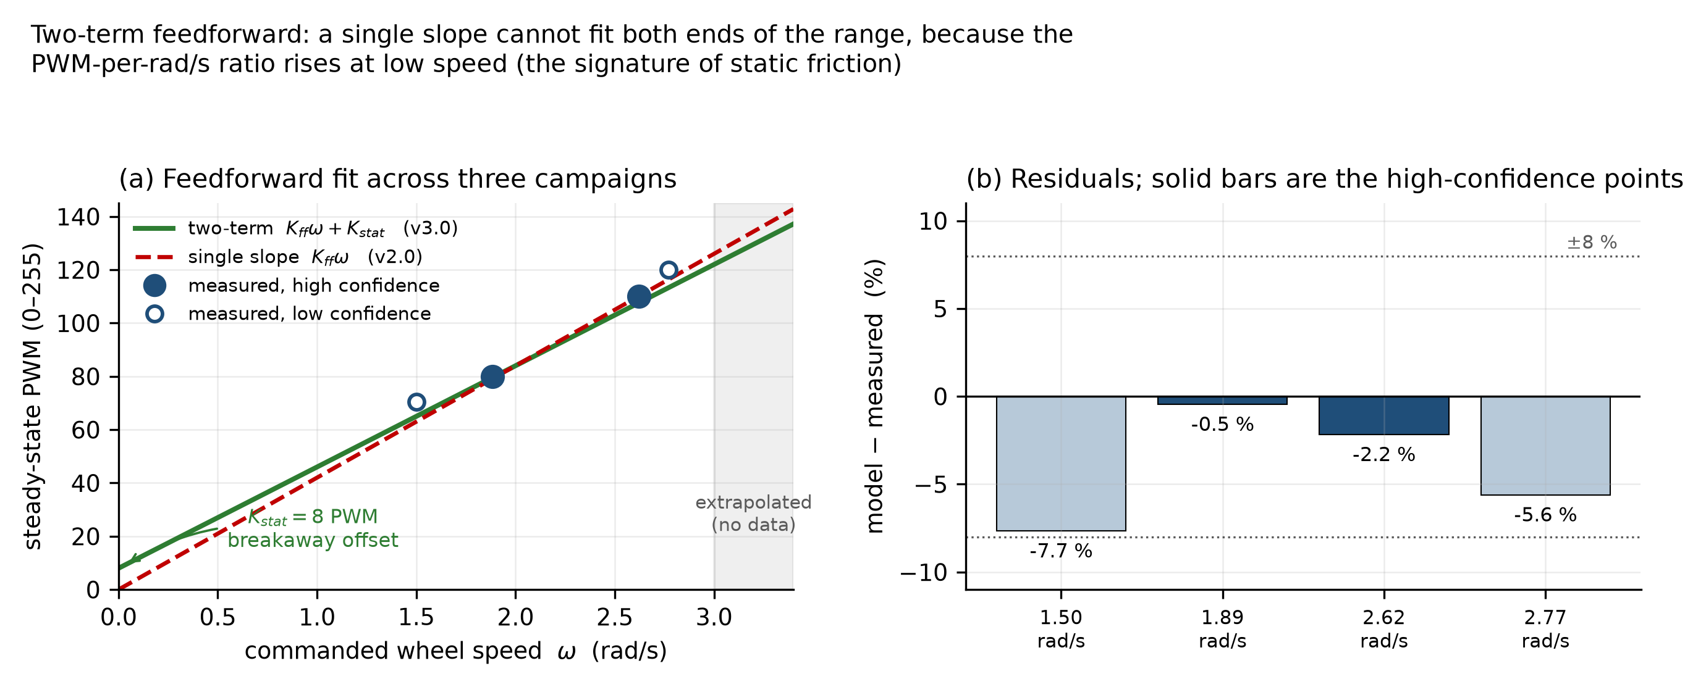
Feedforward model
Figure 7. The two-term feedforward model fitted against measured open-loop data. The static term accounts for breakaway friction and the speed-proportional term for the remaining demand. A single-slope model systematically under-drives the wheels at low speed, which is why the second term is required.
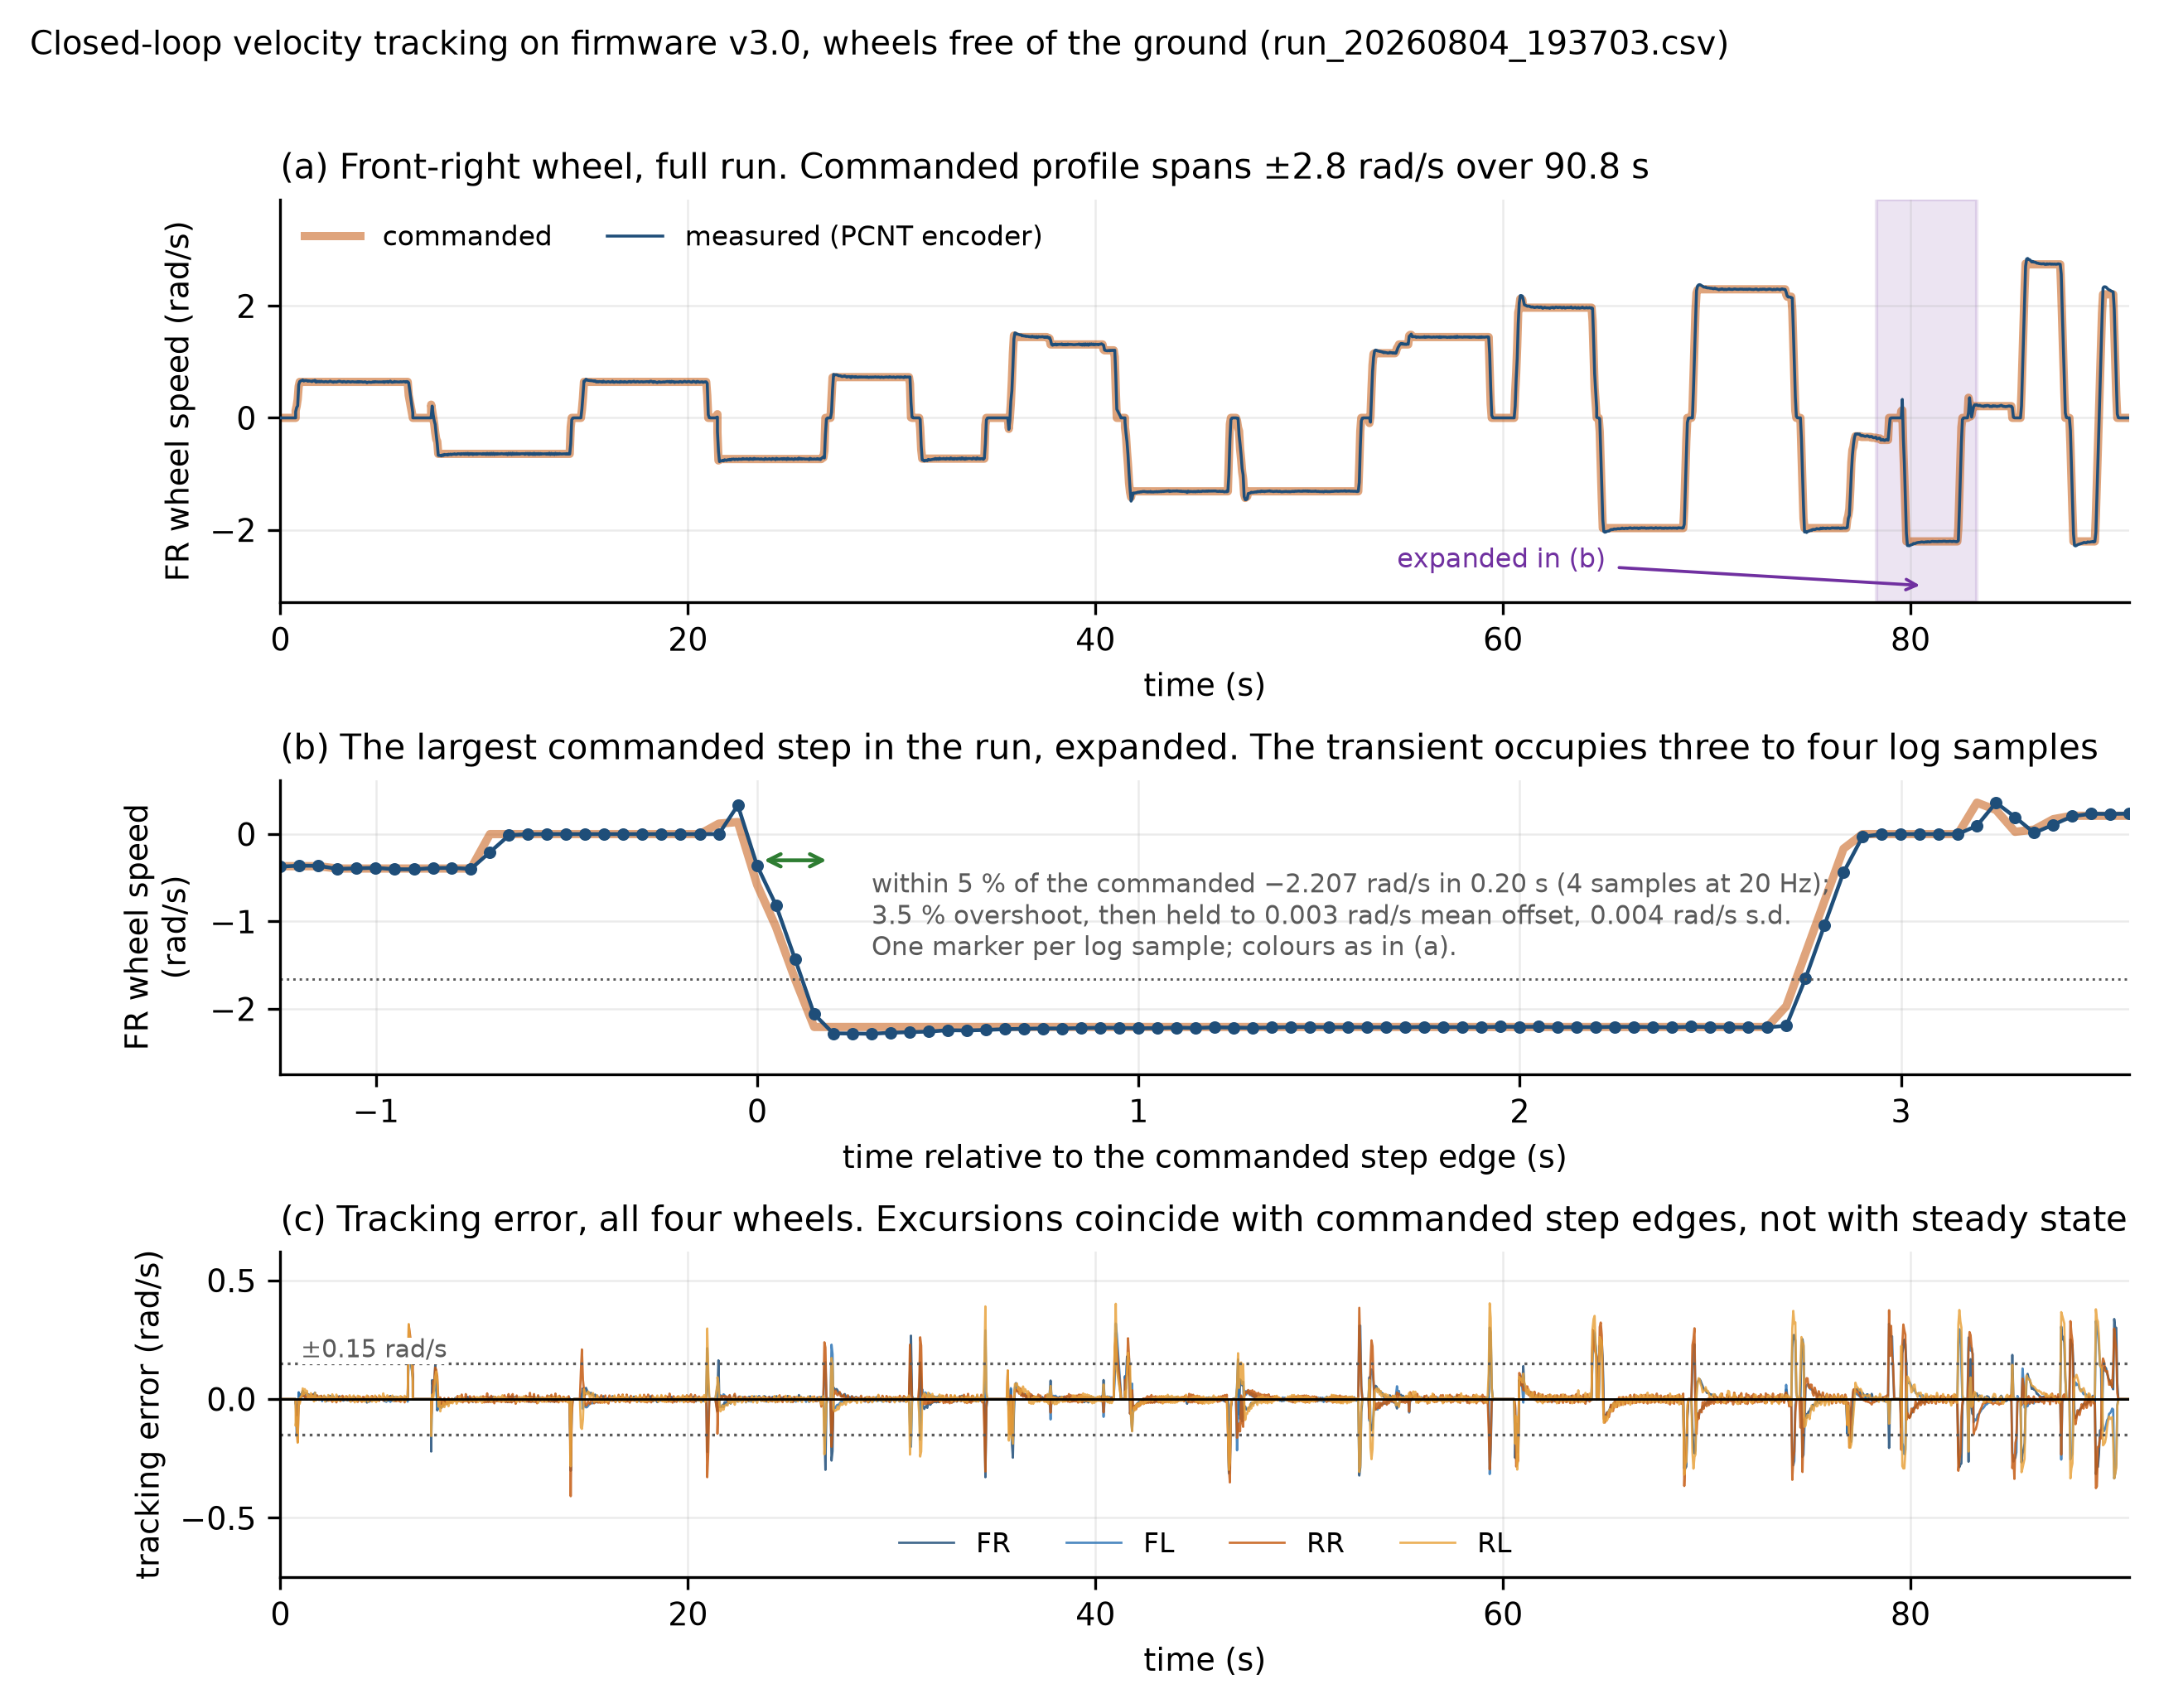
Closed-loop tracking
Figure 8. Closed-loop wheel velocity tracking, wheels free of the ground. Panel (a) is the front-right wheel over the full 90.8 s run, with the shaded band marking the region expanded in panel (b). Panel (b) expands the largest commanded step in the run, plotted against time relative to the step edge with one marker per 20 Hz log sample: the wheel reaches within 5 per cent of the commanded −2.207 rad/s in 0.20 s, overshoots by 3.5 per cent, and then holds the level to a mean offset of 0.003 rad/s. Panel (c) gives the tracking error for all four wheels, showing that the excursions coincide with commanded step edges and not with steady state. The step transient occupies three to four log samples, which is why it appears in (a) as a vertical edge.
Tracking holds on the floor under operator control as well as on the bench. The table below comes from the motor telemetry of the drive shown as Drive C in Figure 10, logged at 20 Hz over 4,713 telemetry rows.
Wheel | RMS error (rad/s) | Mean absolute error (rad/s) | Saturated samples
Front right | 0.077 | 0.039 | 0.0 %
Front left | 0.066 | 0.034 | 0.0 %
Rear right | 0.068 | 0.032 | 0.0 %
Rear left | 0.075 | 0.039 | 0.0 %

No channel saturated at any point in the drive and no feedback channel was lost, so the controller retained authority throughout.
Tracking was evaluated in two conditions, and they are reported separately because the figures differ by about half. With the wheels free of the ground, pooled over three bench runs and 26 468 wheel-samples, per-wheel root-mean-square error is 0.040 to 0.047 rad/s. Under the full chassis weight on the floor, pooled over three runs and 35 248 wheel-samples, it is 0.066 to 0.074 rad/s. The autonomous drive tabulated above falls in the same band as the loaded case, which is the band that matters operationally; the unloaded figure is reported because it separates the controller from the wheel-ground interaction rather than because it is the number the robot works at. No channel saturated in any recorded run, and the largest drive demand observed at the operating velocity limit was 131 of the 255 available, leaving about 49 per cent of the commanded range unused under the tested condition. That is headroom in the command, not a measurement of torque or traction reserve, so it bounds what the controller was asked for rather than what the drivetrain could deliver.
The plant was identified rather than assumed. The measured time constant is approximately 0.09 s, against an initially assumed 0.18 s. Two proportional gains recomputed from the measured constant were both tested against the gain already in service, across sixteen combinations of setpoint and motor, and both produced more overshoot. The original gain was therefore retained on measured evidence rather than changed on theoretical grounds.
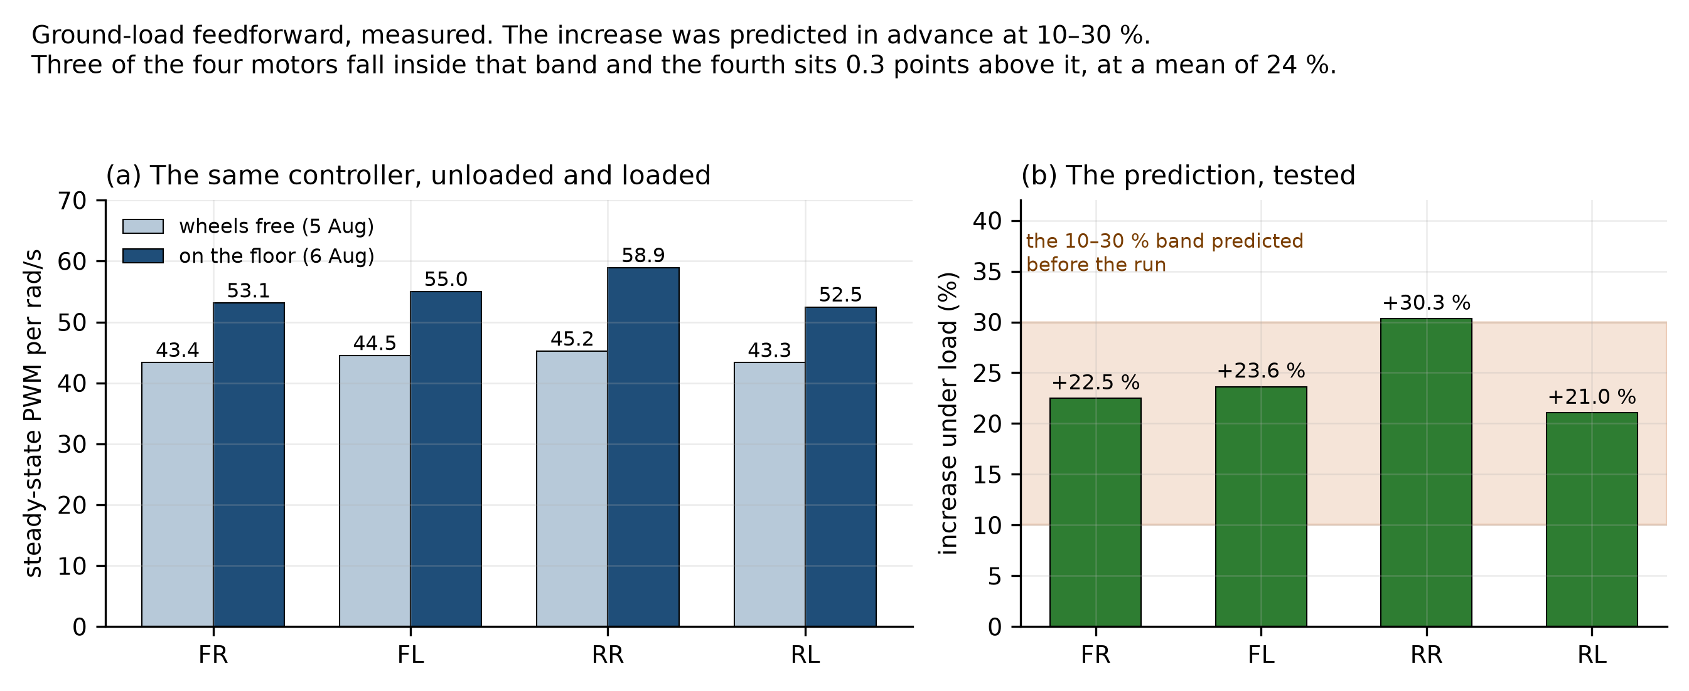
Ground load
Figure 9. Steady-state drive demand per unit wheel speed, unloaded against loaded. The increase under chassis weight was predicted to fall between 10 and 30 per cent before the measurement was made. The measured increases are 22.5, 23.6, 30.3 and 21.0 per cent, a mean of 24: three of the four motors fall inside the predicted band and the rear-right sits 0.3 points above its upper bound.
The ground-load result is stated as a prediction and a test rather than as an observation, because the predicted band was written down before the run. Moving from the unloaded condition to full chassis weight raised the feedforward demand by a mean of 24 per cent, against a band of 10 to 30 per cent set in advance. Three of the four motors fall inside that band. The rear-right reaches 30.3 per cent, which is 0.3 points above the upper bound, and it is reported as an exceedance rather than rounded into agreement. These figures come from the first of three floor runs recorded on 6 August. The two later runs of that afternoon, at the same commanded levels but driven over different patches of floor, give means of 14 and 3 per cent, so the increase is real while its size is not established to better than the width of the band it was predicted against. The likeliest reason is the surface rather than the load: casual driving covers different floor patches and headings, where a staircase test holds position and sweeps demand instead. That test has not been run on the floor, and it is what would settle the figure. The one motor sitting at the edge of the band is worth keeping in view when it is.

6.2 Kinematics and motion estimation
The implemented forward-kinematic transformation was checked against independently generated reference twists across twenty thousand simulated cases. The round trip reproduces them to a worst case of 2.22 × 10⁻¹⁶, which is of the order of machine epsilon for double precision, so the implementation is numerically exact to the limit of the arithmetic it runs on. What this establishes is that the transformation is coded correctly and contributes no numerical error of its own. It says nothing about the physical wheel-ground model, which is what the floor measurements below address.
The odometry integrator was checked the same way. Position was recomputed offline from the raw encoder record for a complete drive and compared against the estimate the robot published live. The two diverge by at most 0.0054 m at any point during the run and by 0.0000 m at its end. The online and offline implementations are therefore numerically consistent, which rules out a discrepancy between them as the source of the observed drift. It does not rule out an error shared by both, since they integrate the same measurements through the same model; that class of error is addressed in the floor measurements and in Section 6.4.
Endpoint closure was then measured on the floor against a tape-measured reference mark rather than against an instrumented ground truth, and the precision of that reference bounds what the numbers mean. Marking and re-reading a floor position by tape and eye is good to a few millimetres at best, so the 4.582 m route closing to 3.1 mm, nominally 0.07 per cent of path, should be read as closure at or below the resolution of the reference rather than as a 3.1 mm measurement. The 38 s square closed to 2.58 cm, which is comfortably above that floor and is a meaningful figure.
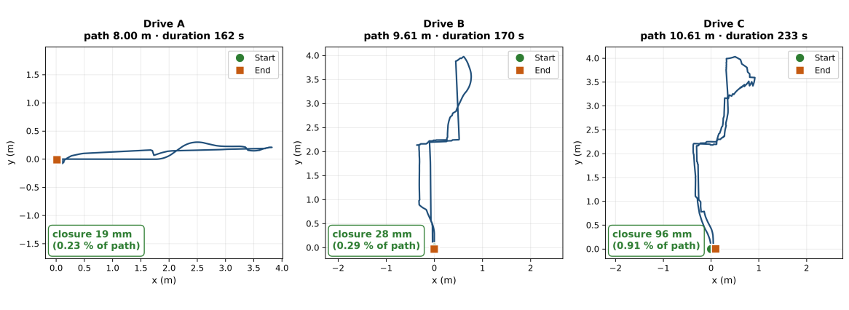
Endpoint closure
Figure 10. Wheel-odometry trajectories for three logged drives, each driven manually under operator control, plotted from the recorded pose. In each case the robot was driven back to its starting mark and the wheel-odometry estimate closed to 19 mm over 8.00 m, 28 mm over 9.61 m and 96 mm over 10.61 m, which is 0.23, 0.29 and 0.91 per cent of path travelled respectively.
Three complete drives logged in the test area are shown in Figure 10. Path lengths range from 8.00 m to 10.61 m over durations of 162 to 233 s, and each closed to within 1 per cent of the distance travelled. The longest of the three, which includes the most rotation, closes at 0.91 per cent; the two shorter routes close at 0.23 and 0.29 per cent.
The sub-1-per-cent figure should not be generalised past the route lengths it was measured on, and the project’s own longest drives are the reason. On an 18 m route the same estimator closed 0.229 m, which is 1.27 per cent, and on a second long route 0.257 m over 18.14 m, which is 1.42 per cent. The honest statement is therefore bounded: closure stays below 1 per cent of path on every route up to about 10 m, reaching roughly 0.1 per cent on short straight runs, and sits between 1.1 and 1.5 per cent on the longest routes driven. Error grows with the amount of rotation a route contains as well as with its length, which is consistent with the increased lateral roller motion expected during rotational manoeuvres. Separating the two effects calls for routes that vary length and rotation independently, which is a direct use for the larger test space.
The yaw-consistency residual of Section 5.4 was evaluated across four analysed drives, one of them a deliberately irregular trajectory rather than a clean circuit. Its median while moving is 0.035 rad/s, with a 95th percentile of 0.111 to 0.124 rad/s and a worst instantaneous value of 0.354 rad/s. No sample in any of the four drives crossed the 0.5 rad/s episode threshold, which is the default of the analysis tool rather than a value derived from the drivetrain, and was fixed before the drives were analysed rather than chosen afterwards. It sits about four times the 95th percentile observed, so it detects gross events and would not resolve a slow systematic drift. Within the sensitivity of this measure, and at the roughly one-per-cent common-mode weighting derived in Section 5.4, the asymmetric geometry is not producing the sustained wheel-fight or scrubbing that might reasonably be expected from a non-symmetric layout. The measure is blind to a slip mode in which all four wheels slip together, which is taken up in Section 6.4.

6.3 Perception
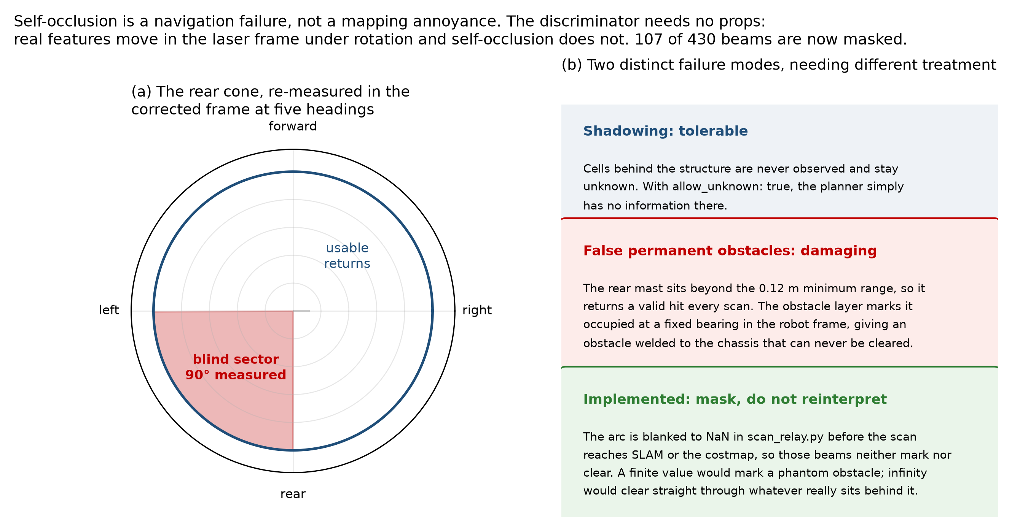
Self-occlusion
Figure 11. The self-occlusion sector, re-measured at five independent headings. The mast and payload block a wedge of approximately 90 degrees, covering 107 of the 430 beams returned per revolution. Unmasked, these returns are interpreted as an obstacle travelling with the robot.
The self-occlusion measurement is consistent across five independent headings and is now handled in software. It is stated here because it is a general consequence of carrying a payload above a single-plane scanner, and because the trade-off between sensor placement, sector masking and accepted coverage loss does not appear to be characterised quantitatively in the literature.
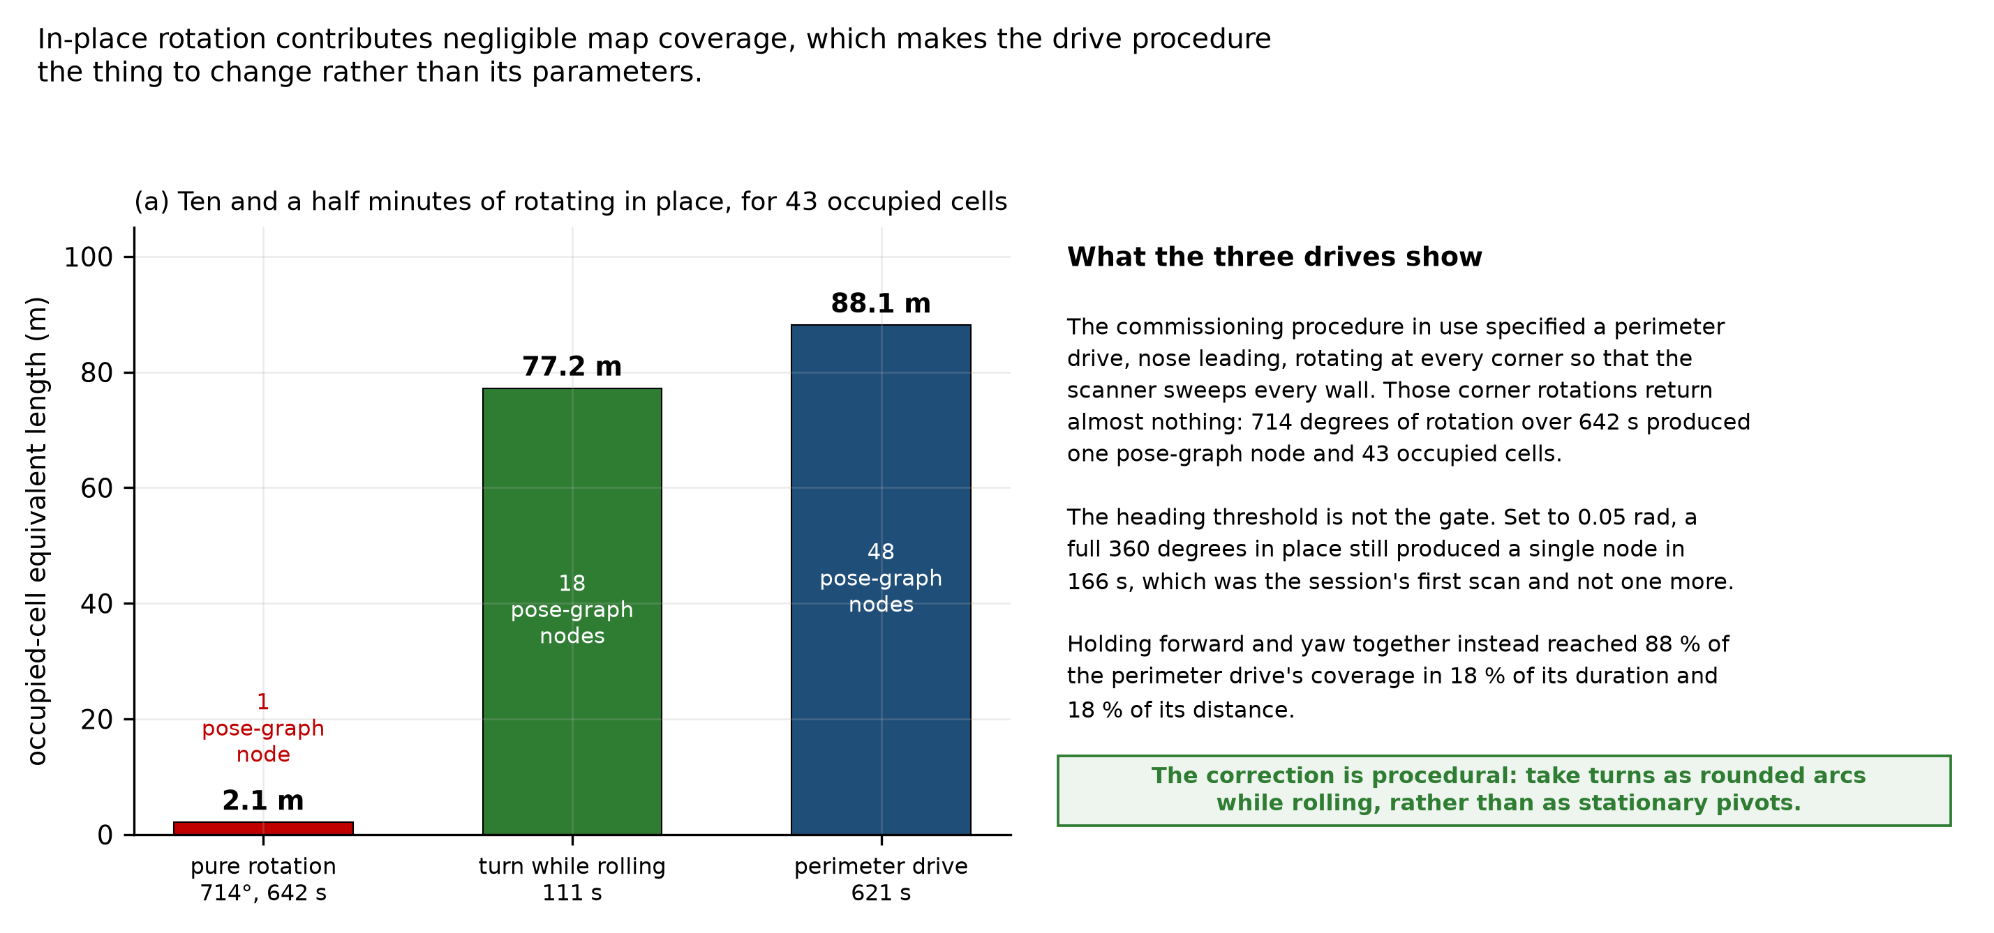
Rotation and mapping coverage
Figure 12. Map coverage accumulated under three drive patterns, measured as occupied-cell count multiplied by the 0.05 m cell size. The quantity is an occupied-cell equivalent length, a proxy for how much occupancy the map has committed to rather than a physical wall length: a single wall rendered several cells thick contributes several times its own length, so the totals exceed the perimeter of the room. Rotation in place contributes almost nothing: a deliberate 714-degree rotation over 642 s produced 43 occupied cells, 2.1 m on this measure. A 111 s arc combining rotation with translation produced 1545 cells, 77.2 m, which is 88 per cent of what a full perimeter drive accumulates in 18 per cent of its duration.
This is the most operationally consequential perception result obtained. The commissioning procedure in use had specified rotating in place at each corner to survey the space. That procedure discards its own corner observations: under the deployed mapping configuration, rotation in place contributed almost no new occupied cells, measured across three separate runs. The effect is a property of that configuration rather than of lidar in general, since the thresholds governing when a scan is integrated and when a pose-graph node is inserted are both motion-dependent, and neither was varied here. It is nonetheless the configuration the robot maps in, so the procedural consequence stands: coverage accumulates through translation, and turns must be taken as rounded arcs while rolling rather than as stationary pivots. Correcting the procedure requires no hardware modification, and it was the highest-value procedural change identified during this work.

6.4 Mapping, and the constraint imposed by the available workspace
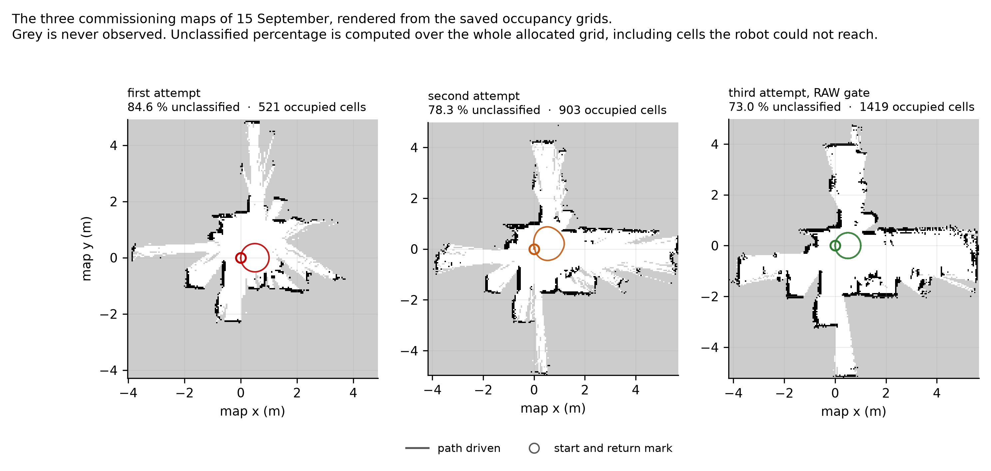
Commissioning maps
Figure 13. The three commissioning maps of 15 September, rendered from the saved occupancy grids. Within the classified regions the recovered wall geometry is consistent across all three runs and with the layout of the room, and the robot returns to its starting mark in each case. The grey regions are cells that never accumulated enough observation to be classified, and they are the criterion that fails on all three. The driven path is visible as a small loop near the origin in each panel, which is the coverage problem seen directly: the robot cannot classify what it cannot drive past.
Maps are produced repeatedly and reliably, and within the regions that accumulate enough observation to be classified, the wall geometry they recover is consistent across the three runs and with the layout of the room. Four acceptance criteria were defined for a commissioning map before the mapping work began: that the map is not folded, that doubled walls occupy less than 1 per cent of occupied cells, that unclassified cells occupy less than 50 per cent of the mapped area, and that the robot returns to its starting mark within 0.15 m. These are engineering acceptance thresholds set by this project, not values taken from the literature. The 0.15 m return figure is the one with a physical basis, being the order of clearance the target aisle geometry allows; the other three were chosen as the condition a map would have to reach before attempting localisation against it was worthwhile. They are stated here so the results below are read against a bar fixed in advance.
The three maps of Figure 13 are the commissioning attempts of 15 September, and every figure quoted here is computed from the occupancy grids they show. None of the three is folded, and return to mark passes comfortably on each, the best measured at 6.4 mm. Doubled walls measure 0.7, 0.8 and 2.9 per cent of occupied cells, so two of the three clear the 1 per cent bar and the third misses it by close to a factor of three. The spread is itself informative: the run with the best coverage is the one with the worst doubled-wall figure, because it was driven with the loosest lidar quality gate. Tightening that gate did reduce doubled walls, to 1.1 and 0.9 per cent, but it tore the free space into disconnected regions and the map was graded folded, so the looser gate was retained on the grounds that a connected map with thicker walls is more useful than a clean one that has come apart.
The fourth criterion, coverage, is the one the available test area governs directly. Unclassified cells occupy 73.0, 78.3 and 84.6 per cent of the mapped area against a threshold of 50. Coverage accumulates through translation past surfaces, and the circuit available here is a few metres of it, much of the boundary furniture rather than continuous wall. The robot classifies what it drives past, so the figure is a statement about the space rather than about the mapping layer.
The denominator matters and is stated here because it qualifies the figure. The percentage is computed over every cell in the published occupancy grid, which is the bounding extent the mapper has allocated rather than the traversable floor area. Cells the robot could never reach or see are counted in the denominator, so the figure is sensitive to how large a window the mapper happens to allocate and overstates the fraction of reachable space left unobserved. It is used here because it is the criterion that was written down before the mapping work began and because the same definition applies to every run compared, which makes the run-to-run comparison valid even where the absolute number is soft. A coverage criterion computed over a fixed region of interest corresponding to the traversable area would be the better measure and is owed.
Coverage is the criterion that fails on all three runs, and the dominant limiting mechanism is consistent with the coverage dependence measured in Section 6.3 and with the restricted geometry of the available test area. Coverage accumulates through translation past surfaces, at a rate set by how much distance the robot can travel while observing new geometry. The laboratory area available for this work permits a traversable circuit of only a few metres, much of it bounded by furniture rather than by continuous wall. A drive confined to that circuit cannot accumulate the observation the coverage criterion requires, however well the platform performs, because the criterion is a statement about how much of the mapped area has been seen and the robot cannot see what it cannot drive past.
What follows is concrete in kind if not yet in magnitude. Validating the mapping and localisation layers requires a test space offering a continuous traversable loop with unobstructed wall on at least one side and aisle widths representative of the target application. An initial target of fifteen to twenty metres of path is proposed on the grounds that it is several times the few metres currently available, not derived from a measured coverage-accumulation rate; establishing that rate, and with it the path length a 50 per cent coverage criterion actually demands, is itself one of the first measurements the new space would support. Securing such a space is the principal practical prerequisite for the next stage of the work, and it is the reason the localisation mode that depends on a saved map has not yet been exercised.
Two further findings from the mapping work changed a design decision, and both are given with their evidence.
Scan matching was measured against wheel odometry rather than assumed better. Scan matching is the mechanism by which lidar precision is meant to reach the pose estimate. Here it increased pose error instead of reducing it. The comparison was made twice, at two scales, with the robot physically returned to a marked start point and the closure measured against that mark.
Route | Range cap | Wheel odometry alone | With the scan-matching front end
38 s square, 1.42 m of path | 10 m | 2.58 cm | 6.2 cm
1047 s drive, 21.85 m of wheel path | 10 m | 0.229 m, 10.53° | 0.477 m, 16.18°
82.5 s circle, 3.193 m of path | 5 m | 16.2 mm, 0.51 % | 206.7 mm, 6.47 %

On the 21.85 m route the front end applied 11.08 m of cumulative correction and roughly doubled the error, by a factor of 2.09 on position and 1.54 on heading. Nineteen loop closures fired during that drive, so the result is not an artefact of a back end that never ran.
The third row is the most tightly controlled of the three and was run last, specifically to test the objection that every earlier measurement had been taken with the range cap at 10 m or more. The cap was reduced to 5 m and verified against the live node before the drive. Both estimates in that row come from the same 3.193 m of driving, the same wheels and the same scans, with the robot physically returned to its mark, so the run carries its own control: the matching-on drive’s own wheel odometry closed at 16.2 mm, which is healthy, and the matched estimate on that same data closed at 206.7 mm. The cap did not rescue the matcher. Four revert criteria had been written down before the drive and three fired; of five keep criteria, the only one met was the one predicted to be neutral.
The mechanism is the part worth reporting. All seventeen corrections in that run fired at a mean odometry spacing of 0.183 m with about a centimetre of spread across the whole drive. They track the creation of pose-graph nodes, not disagreement between scans, and the smallest correction in the run was 106.7 mm against a deployed search half-width of 150 mm. A front end correcting on a metronome is not responding to evidence. That also explains the zero loop closures on a route that returns to its own start, since a closure would arrive off-cadence and none did.
The finding is bounded to what was tested: this scanner, this front-end configuration, and three routes of which two are tight circuits that are poor geometry for matching. The project’s own notes flag circle geometry as degenerate for a matcher, because a circle shows the same walls from continuously rotating vantage points, so the third row cannot separate a matcher that fails on this robot from one that fails on circles. A one-variable comparison on the 12.04 m perimeter route, against an existing matching-off baseline on identical geometry, is still owed. Stating the result as a property of scan matching in general would go past the evidence.
Photogrammetry separated two error classes that had been treated as one. Heading at the end of a drive was measured from video against world-static floor features, using tile-grout orientation as the reference, since the alignment criterion used throughout this work is the chassis edge parallel to the tile line. Frames were extracted with ffmpeg, position taken from a threshold centroid on floor brackets, and heading from a gradient-orientation histogram on the grout lines. The instrument was validated before its output was believed, on frames where the commanded rotation was known: it returned −27.07° against a commanded −28.0°, and −18.50° against −19.4°, agreeing within one degree in both cases. That agreement is the only uncertainty estimate available for the method, so its resolution is taken as of order one degree, which is what makes the 3.85° and 4.49° results below interpretable: they are several times the instrument’s demonstrated agreement, not comparable to it. Two failure modes were found and corrected during that validation, the first of them measuring the robot against a camera mounted on the robot’s own mast, which by construction reports no rotation at all.
On two structurally different routes, wheel odometry, the published estimate and the SLAM pose all reported 3.85° and 4.49° of heading change by the end of the drive, while the floor, read photogrammetrically against the tile grout, put the robot within 0.03° of the heading it started from. The robot came back to its heading. The estimators did not. Three estimates agreeing with one another while all three disagree with the floor is the signature of an error they share, not one that separates them.
What that narrows the error to should be stated carefully, because the obvious reading is stronger than the evidence. The yaw-consistency residual rules out significant differential slip between wheels, and the offline re-integration rules out an integration fault. The two leading candidates that remain are an encoder or wheel-radius scale error, which is estimator error and is recoverable by calibration, and a slip mode in which all four wheels slip together and the platform’s motion stays rigid, which is physical and is not. The elimination is not exhaustive: a geometric parameter error, a systematic mounting offset or a timing error between the encoder and pose streams would produce a similar signature and have not been separately excluded. No instrument currently fitted to the robot can distinguish any of them. That is the specific reason an independent heading reference is the next measurement rather than a general improvement, and it is taken up in Section 6.6.

6.5 Autonomous navigation
Autonomous point-to-point navigation has been demonstrated on the platform within a live mapping session. The demonstration is preliminary and the number of trials is small, so it is reported as what it is rather than as a validated capability. The first complete autonomous round trip was performed in August: the robot drove out, reversed its heading and returned, holding direction to within 5.5 and 3.7 degrees on the two legs and stopping 4.6 cm short of the commanded stop point. In later trials goals were selected by tapping the map in the dashboard and the platform reached them in 21 and 26 s respectively. Three goals were commanded across three trials and all three were reached. Establishing a success rate, a stopping-error distribution and behaviour against obstacles requires a larger trial count in a space that permits varied routes, which places this alongside the mapping work behind the same test-space constraint.
The operator interface was verified geometrically rather than by eye. The transformation from a tapped screen pixel to a world coordinate was tested across the full round trip against its analytic value at three different display pixel densities, and agrees to within one part in a million, which over the extent of the test map is well under a millimetre. This is a check that the transformation is coded correctly, not a statement about pointing accuracy, which is set by the size of a fingertip against the map scale and was not measured.
Navigation currently operates within a live mapping session rather than against a previously saved map, for the reason given in Section 6.4.

6.6 Operating without an inertial sensor
The platform carries no inertial measurement unit. That was a decision rather than an omission, and it is worth setting out, because it is the first question the estimator results invite.
Objective 2 asks for a pose estimate characterised against an independently measured physical reference, with a stated drift figure over a stated distance and an explicit account of which sensors are required to reach it. The third clause is the research content, and it is a question about sensors rather than a requirement to own one. Fitting inertial measurement at the start would have removed the ability to answer it. Fusion improves the estimate; without a characterised unfused baseline at the operating scale there is no way to say by how much, or which error it removed. The unfused platform is that baseline.
Which instrument binds the error at the 5 m operating scale is not something this year’s data settles, and the report does not claim it does. Endpoint closure was not measured at 5 m: the routes driven were either short and straight, closing to roughly 0.1 per cent, or long and rotation-heavy, closing at 1.1 to 1.5 per cent, and applying either rate to an intermediate distance is extrapolation rather than measurement. The scanner is characterised on its own terms instead. Its stationary ray scatter is 22.3 mm in the 1.5 to 2.0 m band in one 60 s capture and 31.9 mm in a second capture taken from a differently obstructed position, the latter failing the 25 mm half-cell criterion the mapping configuration implies. Beyond 2.5 m neither capture agrees with the other. What that establishes is that the scanner is unreliable at the ranges a corridor-width map depends on, not that it is the larger of two quantified error terms. Both estimators have limitations at the intended scale, and separating their contributions needs the third measurement an inertial sensor would provide.
What an inertial sensor would add is specific, and the measurement of Section 6.4 gives it a target. Heading errors of 3.85° and 4.49° were invisible to every instrument on the robot, because all of them derive from the same wheel measurements. A rate gyroscope measures angular rate independently of the wheels; integrating it gives a heading estimate that drifts with bias but that does not share the wheel-derived error, and that is what would make this class of error observable and separate an encoder scale error from a rigid all-wheel slip mode. That is the falsifiable test, and it can only be run against a baseline that already exists.
What is not claimed is that the platform is better off without one. Fusion would reduce heading error, an inertial sensor is the right next purchase, and nothing here argues otherwise. The claim is about order of work. Objective 2 therefore closes as characterised rather than as optimal, and inertial measurement with fused state estimation is the first item of Chapter 7, now carrying a specific number to be tested against rather than a general expectation.

6.7 Present state of the platform
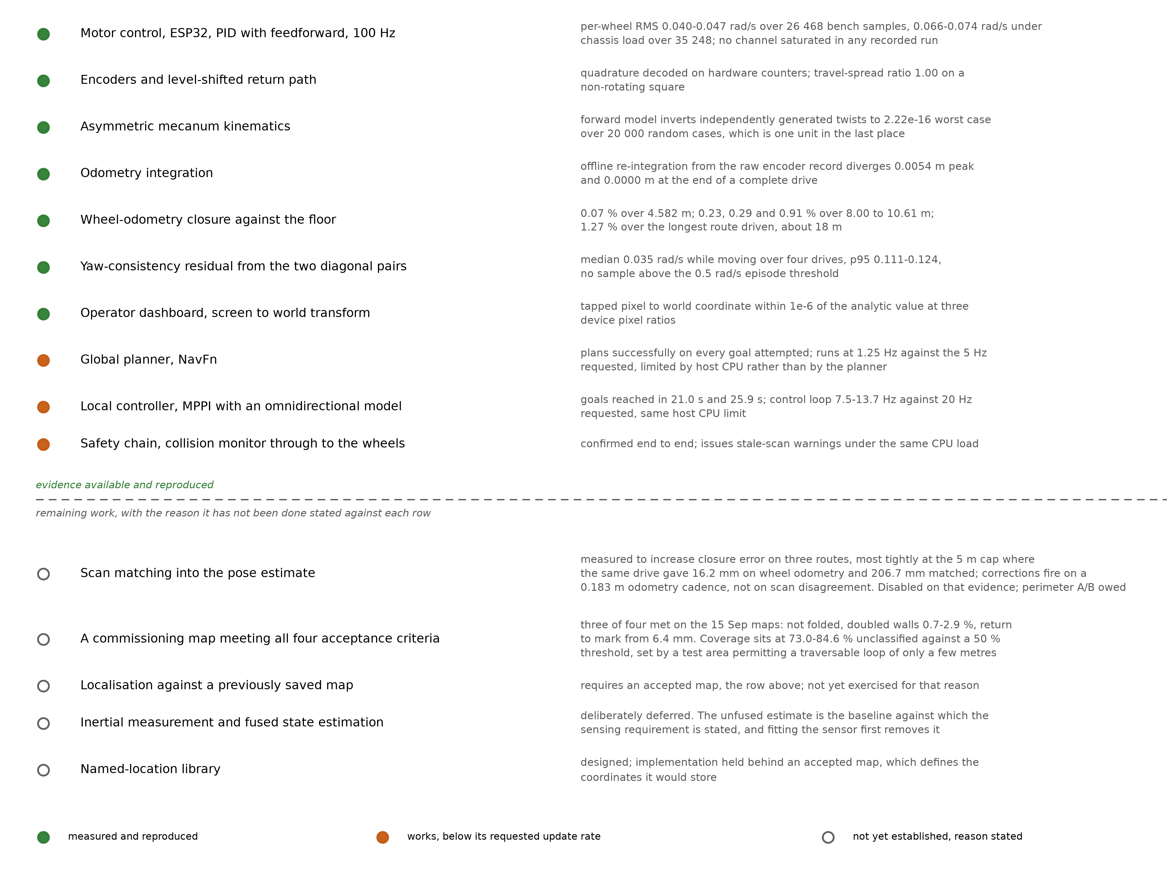
System validation status
Figure 14. Evidence status of each layer of the system, with the measurement given beside each entry. The evidence is not all of one kind: closure against the floor is an external reference, the kinematics and odometry rows are checks against an independent implementation, and the planner, controller and safety rows are operational demonstrations rather than measurements against a reference. Three components work but run below their requested update rates. For the five layers that are not yet established, the entry states the specific reason rather than recording a failure; in three of those five the reason is the size of the available test area rather than anything on the platform.
The layers below the map are measured and working: the motors track, the encoders are clean, the kinematic and odometry implementations are numerically consistent to machine precision across the cases tested, the frame composition reproduces to four decimal places, the planner plans, the local controller reaches goals, and the operator interface is geometrically correct. Wheel odometry, which is the least expensive sensing on the platform, is currently its most extensively characterised source of state estimation.
Figure 14 states the evidence against every layer, and what it shows is that the work still open resolves to two constraints rather than to a list of separate shortfalls.
The first is the size of the available test area. Coverage accumulates through translation past surfaces, at a rate set by how far the robot can drive while observing new geometry, and the laboratory available for this work permits a traversable circuit of only a few metres. That single limit propagates: it holds the coverage criterion below its threshold, which withholds an accepted commissioning map, which in turn leaves localisation against a saved map unexercised and gives the named-location library no coordinates to store. Four entries in Figure 14, and one cause. No further work on the platform moves any of them, and a test space offering a continuous traversable loop lifts all four together.
The second is the deliberate absence of inertial measurement, for the reason set out in Section 6.6. Working without it is what made the unfused baseline measurable, and the cost is one specific error class that stays unobservable to a wheel-only instrument set. Adding the sensor is the first item of Chapter 7 and it now has a measured target to be tested against.
Three further components, the global planner, the local controller and the safety chain, work correctly but run below their requested update rates because of the processing available on the host computer. That is a property of the computer rather than of the software, and a faster host raises all three.
Scan matching is the one entry that is switched off by choice rather than by constraint, on the measurement reported in Section 6.4.

6.8 Environmental monitoring system
The monitoring system is deployed and operating across four zones in two radio-isolated installations sharing one database. All three communication channels, both control paths and the dashboards are in service, and the system recovers automatically after a power interruption without intervention.
The control law was checked against the deployed system rather than asserted, although what that check establishes should be stated precisely. A dashboard capture taken during operation shows the gas index below the configured actuation threshold with the lamp correspondingly off, and the carbon dioxide reading at the same instant above its alert threshold with the node having raised an alert on all three channels. That is a single consistent operating state, and it demonstrates that the deployed logic produces the configured actuator and alert states for the inputs present at that instant. It is not a time-resolved measurement of the loop responding to a change, which would require logging the measurement, the threshold crossing, the actuator command and the resulting response on one time axis. That recording has not been made.
One limitation is recorded plainly. The non-selective gas index that drives the present control law is a relative signal rather than a calibrated concentration, adequate for actuation and trend observation but not for any quantitative claim. This is documented, and addressing it is part of the work described in Chapter 7.

Chapter 7

7.1 Future Work
Securing a representative test space. The coverage limitation of Section 6.4 is the binding constraint on the mapping and localisation layers, and it is environmental rather than technical. A continuous traversable loop with unobstructed wall on at least one side and aisle widths representative of the application is required before the commissioning criteria can be assessed meaningfully. An initial target of fifteen to twenty metres of path is proposed, on the grounds that it is several times the few metres currently available rather than derived from a measured coverage-accumulation rate. Arranging access to such a space is the first practical task.
Inertial measurement and fused state estimation. The photogrammetric result of Section 6.4 leaves two candidate explanations for several degrees of heading error that every fitted instrument misses: an encoder or wheel-radius scale error, which calibration can remove, or a rigid slip mode in which all four wheels slip together, which it cannot. Separating them needs an angular-rate measurement that does not derive from the wheels. Adding an inertial sensor near the geometric centre, where the rotationally induced terms in the accelerometer channel are smallest, and fusing its integrated rate with the wheel estimate is the direct response, and for the reason given in Section 6.6 it is the right next step rather than something that should have come first. The 3.85° and 4.49° already measured give a specific quantity against which the improvement can be tested.
Sensor comparison. The case against the present lidar is now quantitative rather than impressionistic. Repeating the same routes with a higher-grade scanner, using the same analysis tools, would convert that inference into a controlled result and would establish what sensing this class of platform actually requires. That question is currently answered in the literature by convention rather than by measurement.
Completing the geometric comparison. No asymmetry-specific penalty has been detected in any experiment performed so far: the transformation is implemented correctly to the limit of double precision, tracking is clean on every axis including lateral and rotational motion, endpoint closure holds below 1 per cent on the three logged drives up to 10.61 m and to 1.1 to 1.5 per cent on the longest routes driven, and no yaw-consistency residual above the episode threshold has been observed. A matched symmetric baseline has not been tested, so the effect of the asymmetry itself remains unquantified. What has not been performed is a controlled side-by-side comparison against a symmetric layout of matched mass, wheel and controller parameters. Building that baseline, in simulation first and on hardware if the wheelbase can be reconfigured without a new chassis, would convert a consistent absence of penalty into a measured result and would close Objective 3.
Extending the platform to warehouse tasks. The chassis is intended as a general-purpose autonomous base, with task capability delivered by attachments. Inventory scanning, environmental survey, surface disinfection and cargo transfer are the intended applications, and each requires integration work on top of the autonomy layer rather than changes to it.
Developing the monitoring system toward storage applications. The architecture is intended to transfer beyond the unit it was built for. Cold-chain storage, controlled-atmosphere rooms used for produce ripening, and general warehouse environmental survey call for the same measurement set and the same resilience to intermittent connectivity, although the system has so far been deployed in one application and transferability is a design expectation rather than a demonstrated result. Traceable calibration of the measurement channels and a buffered store-and-forward path, so that an outage costs latency rather than data, are the next steps.
Implementing the contactless fatigue framework. This strand currently consists of a hypothesis and a completed literature survey. The implementation begins with a single-subject capture arrangement at a fixed location, such as an aisle end or doorway, so that each crossing yields one clean measurement rather than requiring continuous tracking of several people at once. Laboratory validation of each modality against a direct physical measure of fatigue precedes any deployment, and the fused estimate must be shown to outperform a simple baseline derived from ambient conditions and hours worked before the approach can be considered established.

7.2 Year-One Conclusions
The year produced a full-scale asymmetric mecanum platform with calibrated wheel-level control, an implementation of the non-collinear kinematics verified against an independent reference, wheel odometry characterised against physical floor marks, a measured account of the scanner’s limitations, a preliminary demonstration of autonomous navigation, and a deployed environmental monitoring system operating across four zones.
Four results are established rather than asserted. The velocity controller tracks to 0.040 to 0.047 rad/s root-mean-square unloaded and 0.066 to 0.074 under chassis weight, with no channel saturating in any recorded run. The kinematic and odometry implementations are numerically consistent to machine precision across twenty thousand generated cases and against an offline re-integration of a complete drive. Wheel-odometry endpoint closure stays below 1 per cent of path to about 10 m and sits between 1.1 and 1.5 per cent on the longest routes driven. Scan matching was measured to increase pose error on three separate routes, most tightly on a drive where the same wheels and the same scans gave 16.2 mm unmatched and 206.7 mm matched, with corrections firing on a fixed odometry cadence rather than on scan disagreement.
Three things remain unresolved, and the reasons differ. A commissioning map meeting all four acceptance criteria and localisation against a saved map are blocked by the size of the available test area, not by the platform. The effect of the asymmetric geometry itself is unquantified, because no matched symmetric baseline has been built. And several degrees of heading error survive every instrument currently fitted, narrowed to an encoder or wheel-radius scale error or a rigid all-wheel slip mode, which cannot be separated without an independent angular-rate measurement.
The question Year 2 tests follows directly from the last of those. Adding inertial measurement to a platform whose unfused behaviour is now characterised gives a specific quantity to test the improvement against, rather than a general expectation that fusion helps.

Bibliography
1. Arunkumar, G. K., Devkar, S., Vachhani, L., & Kunwar, A. (2024). An omnidirectional asymmetric mobile robot for narrow aisle spaces. 2024 Tenth Indian Control Conference (ICC), IISER Bhopal, India, 18–23.
2. Galati, R., Mantriota, G., & Reina, G. (2022). Adaptive heading correction for an industrial heavy-duty omnidirectional robot. Scientific Reports, 12(1), 19608.
3. Lin, L.-C., & Shih, H.-Y. (2013). Modeling and adaptive control of an omni-mecanum-wheeled robot. Intelligent Control and Automation, 4, 166–179.
4. Cao, G., Zhao, X., Ye, C., Yu, S., Li, B., & Jiang, C. (2022). Fuzzy adaptive PID control method for multi-mecanum-wheeled mobile robot. Journal of Mechanical Science and Technology, 36(4), 2019–2029.
5. Vlantis, P., Bechlioulis, C. P., Karras, G., Fourlas, G., & Kyriakopoulos, K. J. (2016). Fault tolerant control for omni-directional mobile platforms with 4 mecanum wheels. IEEE International Conference on Robotics and Automation, 2395–2400.
6. Macenski, S., & Jambrečić, I. (2021). SLAM Toolbox: SLAM for the dynamic world. Journal of Open Source Software, 6(61), 2783.
7. Grisetti, G., Stachniss, C., & Burgard, W. (2007). Improved techniques for grid mapping with Rao-Blackwellized particle filters. IEEE Transactions on Robotics, 23(1), 34–46.
8. Kohlbrecher, S., von Stryk, O., Meyer, J., & Klingauf, U. (2011). A flexible and scalable SLAM system with full 3D motion estimation. IEEE International Symposium on Safety, Security and Rescue Robotics, 155–160.
9. Heß, W., Kohler, D., Rapp, H., & Andor, D. (2016). Real-time loop closure in 2D LIDAR SLAM. IEEE International Conference on Robotics and Automation, 1271– 1278.
10. Konolige, K., Grisetti, G., Kümmerle, R., Burgard, W., Limketkai, B., & Vincent, R. (2010). Efficient sparse pose adjustment for 2D mapping. IEEE/RSJ International Conference on Intelligent Robots and Systems, 22–29.
11. Laksono, P. S., & Kusuma, T. M. (2022). Performance analysis of Hector SLAM and GMapping for mobile robot navigation. Jurnal Ilmiah Teknologi dan Rekayasa, 27(2), 144–153.
12. Sugiura, K., & Matsutani, H. (2021). An FPGA acceleration and optimization techniques for 2D LiDAR SLAM algorithm. IEICE Transactions on Information and Systems, E104.D(6), 789–800.
13. Sugiura, K., & Matsutani, H. (2022). A universal LiDAR SLAM accelerator system on low-cost FPGA. IEEE Access, 10, 26931–26947.
14. Censi, A. (2008). An ICP variant using a point-to-line metric. IEEE International Conference on Robotics and Automation, 19–25.
15. Grisetti, G., Kümmerle, R., & Stachniss, C. (2010). A tutorial on graph-based SLAM. IEEE Intelligent Transportation Systems Magazine, 2(4), 31–43.
16. Moravec, H., & Elfes, A. (1985). High resolution maps from wide angle sonar. IEEE International Conference on Robotics and Automation, 116–121.
17. Macenski, S., Martín, F., White, R., & Ginés Clavero, J. (2020). The Marathon 2: A navigation system. IEEE/RSJ International Conference on Intelligent Robots and Systems.
18. Lu, D. V., Hershberger, D., & Smart, W. D. (2014). Layered costmaps for context-sensitive navigation. IEEE/RSJ International Conference on Intelligent Robots and Systems, 709–715.
19. Fox, D., Burgard, W., & Thrun, S. (1997). The dynamic window approach to collision avoidance. IEEE Robotics and Automation Magazine, 4(1), 23–33.
20. Li, X., Liu, F., & Liu, J. (2017). Obstacle avoidance for mobile robot based on improved dynamic window approach. Turkish Journal of Electrical Engineering and Computer Sciences, 25, 666–676.
21. Williams, G., Drews, P., Goldfain, B., Rehg, J. M., & Theodorou, E. A. (2016). IEEE Aggressive driving with model predictive path integral control. International Conference on Robotics and Automation, 1433–1440.
22. Williams, G., Drews, P., Goldfain, B., Rehg, J. M., & Theodorou, E. A. (2018). Information-theoretic model predictive control: theory and applications to autonomous driving. IEEE Transactions on Robotics, 34(6), 1603–1622.
23. Venugopal, V., Chinnadurai, J., Lucas, R. A. I., & Kjellstrom, T. (2016). Occupational heat stress profiles in selected workplaces in India. International Journal of Environmental Research and Public Health, 13(1), 89.
24. Krishnamurthy, M., et al. (2017). Occupational heat stress impacts on health and productivity in a steel industry in Southern India. Safety and Health at Work, 8(1), 99–104.
25. Dutta, P., et al. (2015). Perceived heat stress and health effects on construction workers. Indian Journal of Occupational and Environmental Medicine, 19(3), 151– 158.
26. Balakrishnan, K., et al. (2010). Case studies on heat stress related perceptions in different industrial sectors in southern India. Global Health Action, 3, 5635.
27. Guo, Y., Chen, X., Gong, P., et al. (2023). Advances in postharvest storage and preservation strategies for Pleurotus eryngii. Foods, 12(5), 1046.
28. Hui, P. S., Wong, L. T., & Mui, K. W. (2008). Using carbon dioxide concentration to assess indoor air quality in offices. Indoor and Built Environment, 17(3), 213– 219.
29. Mašić, A., Bibić, D., & Pikula, B. (2019). Evaluation of carbon dioxide sensors for indoor air quality monitoring. Proceedings of the 30th DAAAM International Symposium, 457–459.
30. Hwang, S., Kwon, N., Lee, D., et al. (2025). A multimodal fatigue detection system using sEMG and IMU signals with a hybrid CNN-LSTM-attention model. Sensors, 25(11), 3309.
31. Tashakori, M., Nahvi, A., & Ebrahimian, S. (2021). Driver drowsiness detection using facial thermal imaging in a driving simulator. Proceedings of the Institution of Mechanical Engineers, Part H: Journal of Engineering in Medicine, 236(1), 43– 55.
32. Kartsch, V., Benatti, S., Schiavone, P. D., Rossi, D., & Benini, L. (2018). A sensor fusion approach for drowsiness detection in wearable ultra-low-power systems. Information Fusion, 43, 66–76.
33. Stenum, J., Rossi, C., & Roemmich, R. T. (2021). Two-dimensional video-based analysis of human gait using pose estimation. PLoS Computational Biology, 17(4), e1008935.
34. Shen, C., Fan, C., Wu, W., et al. (2023). LidarGait: benchmarking 3D gait recognition with point clouds. IEEE/CVF Conference on Computer Vision and Pattern Recognition, 1054–1063.
35. Alizadeh, M., Shaker, G., & Almeida, J. C. (2019). Remote monitoring of human vital signs using mm-wave FMCW radar. IEEE Access, 7, 54958–54968.
36. Zhang, J., Xi, R., & He, Y. (2023). A survey of mmWave-based human sensing: technology, platforms and applications. IEEE Communications Surveys and Tutorials, 25(4), 2052–2087.
37. Bordallo López, M., del-Blanco, C. R., & García, N. (2017). Detecting exercise-induced fatigue using thermal imaging and deep learning. IEEE International Conference on Image Processing Theory, Tools and Applications, 1–6.

